**DWP 5431**

**Internet & Web Publishing**

*Trimester 1, Session 2021 / 2022*

Project Title: Marina Bay Hotel

**(Lecture Section:2122)**

BY

|  |  |  |  |  |
| --- | --- | --- | --- | --- |
| **No.** | | **Student ID** | | **Student Name** |
|  | 1201200637 | | Wee Chian Seong | |
|  | 1201200463 | | Lim Wee Zheng | |
|  | 1201200327 | | Ho Chun Shian | |
|  | 1201200678 | | Law Qian Er | |
|  | 1201200449 | | Lai Jian Hong | |

Table of Contents

**TABLE OF CONTENTS 1**

**TASK DISTRIBUTION FORM 4-5**

**PROJECT EVALUATION FORM 6**

**PART 1: INTRODUCTION 7**

**PART 2: SCREENSHOTS OF THE WEBPAGE 8-57**

**2.1** Public………………………………………………………………………**8-22**

**Figure 2.1.1 Public Homepage Page**………………………………………...**8**

**Figure 2.1.2 Header Navigation Bar**………………………………………...**9**

**Figure 2.1.2.1 Left-side Header Navigation Bar**……………………………**9**

**Figure 2.1.2.2 Right-side Header Navigation Bar**……………………….....**9**

**Figure 2.1.3 Footer Navigation Menu**……………………………………...**10**

**Figure 2.1.3.1 Footer Navigation Menu**……………………………………**10**

**Figure 2.1.3.2 Footer Navigation Menu**……………………………………**11**

**Figure 2.1.4 Room Page**…………………………………………………….**12**

**Figure 2.1.5.1 Superior Room**……………………………………………...**13**

**Figure 2.1.5.2 Deluxe Room**………………………………………………...**14**

**Figure 2.1.5.3 Couple Room**………………………………………………..**15**

**Figure 2.1.5.4 Signature Room**………………………………………...…...**16**

**Figure 2.1.6 Hotel Guest Registration Form**………………………………**17**

**Figure 2.1.7 Payment Form**………………………………………………...**17**

**Figure 2.1.7.1 Payment Form**…………………………………………...…**18**

**Figure 2.1.8 Successful Payment Page**……………………………………..**18**

**Figure 2.1.9 About Us Page**………………………………………………...**19**

**Figure 2.1.9.1 About Us Page**………………………………………………**19**

**Figure 2.1.10 Contact Us Page**…………………………………….……….**20**

**Figure 2.1.11 Feedback Form**……………………………………………...**21**

**Figure 2.1.12 Privacy Policy of Hotel**……………………………………...**22**

**Figure 2.1.13 Terms and Conditions of Hotel**……………………………..**22**

**2.2 User________________________________________________________23-41**

**Figure 2.2.1 Hotel Login Page**……………………………………………...**23**

**Figure 2.2.2 Forgot Password Page**………………………………………..**24**

**Figure 2.2.3 Hotel Sign In Page**…………………………………………….**25**

**Figure 2.2.4 User Home Page**………………………………………………**26**

**Figure 2.2.5 Left-side Header Navigation Bar**…………………………….**27**

**Figure 2.2.6 Right-side Header Navigation Bar**…………………………..**27**

**Figure 2.2.7 Footer Navigation Menu**……………………………………...**28**

**Figure 2.2.8 Footer Navigation Menu**……………………………………...**28**

**Figure 2.2.9 Footer Navigation Menu**……………………………………...**29**

**Figure 2.2.10 Hotel Room List Page**……………………………………….**30**

**Figure 2.2.11 Superior Room Page**………………………………………...**31**

**Figure 2.2.12 Deluxe Room Page**…………………………………………..**32**

**Figure 2.2.13 Couple Room Page**…………………………………………..**33**

**Figure 2.2.14 Signature Room Page**………………………………………..**34**

**Figure 2.2.15 Pop-Up Book Form**………………………………………….**35**

**Figure 2.2.16 User Room Cart**……………………………………………..**36**

**Figure 2.2.17 User Payment Page**………………………………………….**36**

**Figure 2.2.18 Payment Form**……………………………………………….**37**

**Figure 2.2.19 Payment successful page**…………………………………….**37**

**Figure 2.2.20 About us Page**………………………………………………..**38**

**Figure 2.2.21 Contact Us Page**……………………………………………..**39**

**Figure 2.2.22 Dashboard Page**……………………………………………...**39**

**Figure 2.2.23 User Comment & Rating**……………………………………**40**

**Figure 2.2.24 Marina Bay Hotel Privacy and Policy Page**………….…….**41**

**Figure 2.2.25 Term and Condition Page**…………………………………..**41**

**2.3 Admin__________________________________________________ 42-57**

**Figure 2.3.1 Admin Login Page**…………………………………………….**42**

**Figure 2.3.2 Forgot Password Page**………………………………………..**42**

**Figure 2.3.3.1 Admin Index Page**…………………………………………..**43**

**Figure 2.3.3.2 Below Part of Admin Index Page**…………………………..**43**

**Figure 2.3.4 Customer Details Page**………………………………………..**44**

**Figure 2.3.5 Edit Customer Page**…………………………………………..**44**

**Figure 2.3.6 Add Customer Page**…………………………………………..**45**

**Figure 2.3.7 Booking Details Page**…………………………………………**45**

**Figure 2.3.8 Edit Booking Page**…………………………………………….**46**

**Figure 2.3.9 Add Booking Page**…………………………………………….**46**

**Figure 2.3.10 Rooms Details Page**………………………………………….**47**

**Figure 2.3.11 Edit Room Page**……………………………………………...**47**

**Figure 2.3.12 Edit Room List Page**………………………………………...**48**

**Figure 2.3.13 Add Room Page**……………………………………………...**48**

**Figure 2.3.14: Staff in Navigation Bar**……………………………………..**49**

**Figure 2.3.15 All Staffs**……………………………………………………...**50**

**Figure 2.3.16 Edit Staff** …………………………………………………….**50**

**Figure 2.3.17 Add Staff** …………………………………………………….**51**

**Figure 2.3.18 Employees in Navigation Bar**……………………………….**51**

**Figure 2.3.19 All Leaves**…………………………………………………….**52**

**Figure 2.3.20 Add Leave**………………………………...………………….**52**

**Figure 2.3.21: Holidays**……………………………………………………..**52**

**Figure 2.3.22 Edit Holiday**………………………………………………….**53**

**Figure 2.3.23 Add Holiday**………………………………………………….**53**

**Figure 2.3.24 Attendance**…………………………………………………...**53**

**Figure 2.3.25 Activities**……………………………………………………...**54**

**Figure 2.3.26 Invoice in Navigation Bar**…………………………………...**54**

**Figure 2.3.27 Create Invoice**………………………………………………..**55**

**Figure 2.3.28 Invoice Report**……………………………………………….**55**

**Figure 2.3.29 Customer’s Receipt**………………………………………….**56**

**Figure 2.3.30 Profile in Navigation Bar**……………………………………**56**

**Figure 2.3.31 Profile**………………………………………………………...**57**

**REFERENCES _____ __________58**

**APPENDIX (Meeting Minutes) _________58-62**

**TASK DISTRIBUTION FORM**

|  |  |  |  |  |
| --- | --- | --- | --- | --- |
| **No.** | **Student ID** | **Student Name** | **Tasks Completed** | **Signature** |
|  | 1201200637 | Wee Chian Seong | public:index.html,navigation bar, payment confirm box,public_term&condition.html, public_privacy.html  user:navigation bar,book now pop out form,navigation bar, hyperlink whole user file, user_cart.html,user_privacy.html,  user_terms&condition.html,  documentation |  |
|  | 1201200463 | Lim Wee Zheng | index_header.css, rooms_header.css, room_detail_slide.css, modified bootstrap.css  public and user:  rooms.html, Superior_Room.html, Deluxe_Room.html, Couple_Room.html, Signature_Room.html,  booking history in dashboard.html,  cart.html  admin:  all-rooms.html, edit-room-list.html, add-room.html, edit-room.html |  |
|  | 1201200678 | Law Qian Er | public：about.html,contact.html,comment&rating.html,footer,designing  user：about.html,contact.html,forget password.html,footer,designing  admin：  index.html,login.html,forgot-password.html,profile.html,add-holiday.html,holiday.html,edit-holiday.html,activities.html,leaves.html,add-leave.html,navigation bar,attendance.html |  |
|  | 1201200449 | Lai Jian Hong | user:  direct_book.html,  hotel_login.html,  hotel_sign_in.html,    admin: all-customer.html,  edit-customer.html,  add-customer.html,  all-staff.html,  edit-staff.html  add-staff.html |  |
|  | 1201200327 | Ho Chun Shian | user:  dashboard.html,  payment2.html  admin:  invoice-reports.html |  |

**DWP5431 Internet & Web Publishing**

**PROJECT EVALUATION FORM**

|  |  |  |  |
| --- | --- | --- | --- |
| **STUDENT ID** | **STUDENT NAME** | **Peer Evaluation Total Marks (20M)**  **(For Evaluator Use)** | **Project + Peer Evaluation**  **(For Evaluator Use)**  **(40M+20M)** |
| **1201200637** | **Wee Chian Seong** |  |  |
| **1201200463** | **Lim Wee Zheng** |  |  |
| **1201200327** | **Ho Chun Shian** |  |  |
| **1201200678** | **Law Qian Er** |  |  |
| **1201200449** | **Lai Jian Hong** |  |  |

|  |  |  |  |  |  |  |  |  |  |
| --- | --- | --- | --- | --- | --- | --- | --- | --- | --- |
| **1** | **Very Poor** | **2** | **Poor** | **3** | **Average** | **4** | **Good** | **5** | **Excellent** |

|  |  |  |
| --- | --- | --- |
| **Criteria** | **Marks** | **Comments/ Remarks** |
| 1. Content (User/Customer)  * Content relevance, appropriateness, organization and presentation |  |  |
| 1. Content (Administrator):  * Content relevance, appropriateness, organization and presentation |  |  |
| 1. Graphics & CSS |  |  |
| 1. Hyperlinks |  |  |
| 1. Form |  |  |
| 1. Extra features (video, javascript) |  |  |
| 1. Overall design |  |  |
| 1. Report (Hard copy & Softcopy) |  |  |
| **Total (40)** |  |  |

**PART 1: INTRODUCTION**

Nowadays, customers want to book rooms without physically walking to the hotel. By using an online hotel booking system, they can make their booking at anytime and anywhere, without having to worry if it is within business hours or not. After that, customers can have more options to choose their preferred hotel. In addition, customers can easily view and visit the rooms of hotels virtually. Not only that, online booking can save money because customers have the ability to easily compare prices for the best possible deal. In addition, they can book first to get a smooth trip. This is because it may happen that the condition of the room is full if they book by booking at a local hotel. Consequently, the schedule of the trip will be affected. By using online booking, they can do research for reviews of hotels that they want to avoid booking a hotel in a bad environment. By using online, customers want to look for their booking history and their personal information can be safely secure.

The distinction of our created website is it can be an online booking without going to the physical hotel. Not only that, rooms can be booked directly without a login account which is convenient for the rushing customers. In addition, the interface of the hotel website is friendly to customers. This is because the website has many of the buttons that are functional. Moreover, customers also can access our website by any device. Other than that, customers can see their booking history that has been booked at their personal dashboard after they log in to our website. After that, we are friendly accept customers' feedback because customers can give feedback at the comment section which is provided at the comment & rating page. Last but not least, customers can also contact our hotel’s staff privately for more detailed information.

**PART 2: SCREENSHOTS OF WEB PAGE**

**2.1 Public Customer Module**

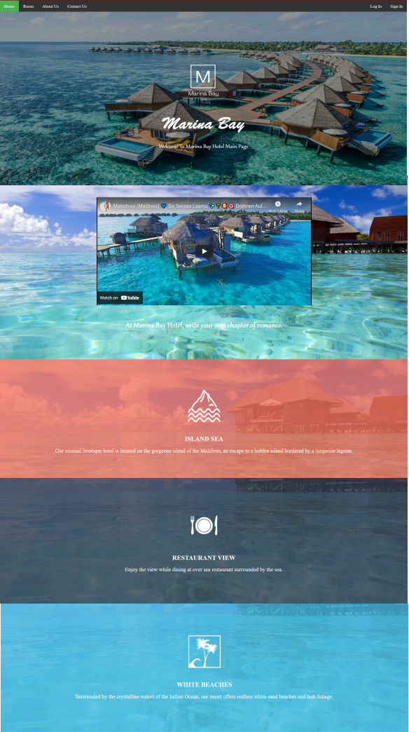

***Figure 2.1.1 Public Homepage Page***

*Figure 2.1.1**show the design for homepage to attract user’s view*

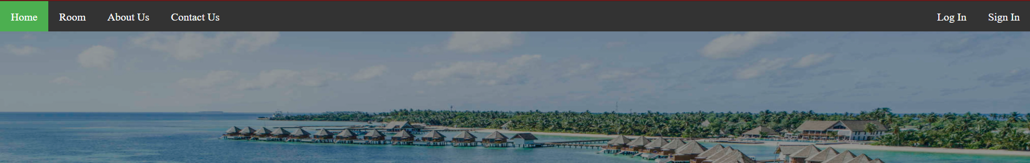

***Figure 2.1.2 Header Navigation Bar***

*Figure 2.1.2**shows the header navigation bar that provides access links to other pages by clicking the menu item.*

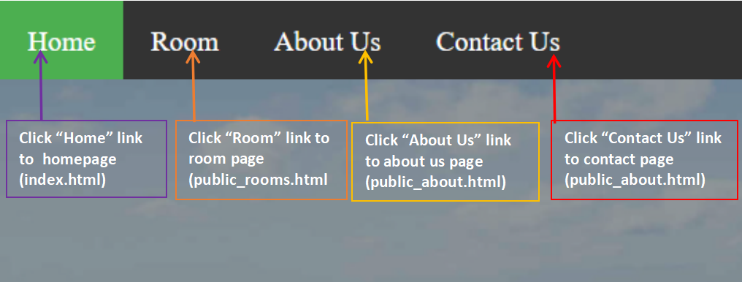

***Figure 2.1.2.1 Left-side Header Navigation Bar***

*Figure 2.1.2**shows the left-side header navigation bar that provides access links to other pages by clicking the menu item.*

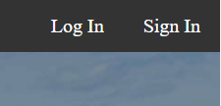

***Figure 2.1.2.2 Right-side Header Navigation Bar***

*Figure 2.1.2**shows the right-side header navigation bar that provides login and sign in access to customers by clicking the item.*

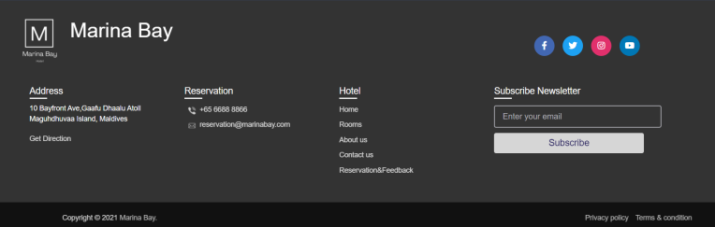

***Figure 2.1.3 Footer Navigation Menu***

*Figure 2.1.3 show the bottom navigation menu that provide access link to other pages by click the menu item*

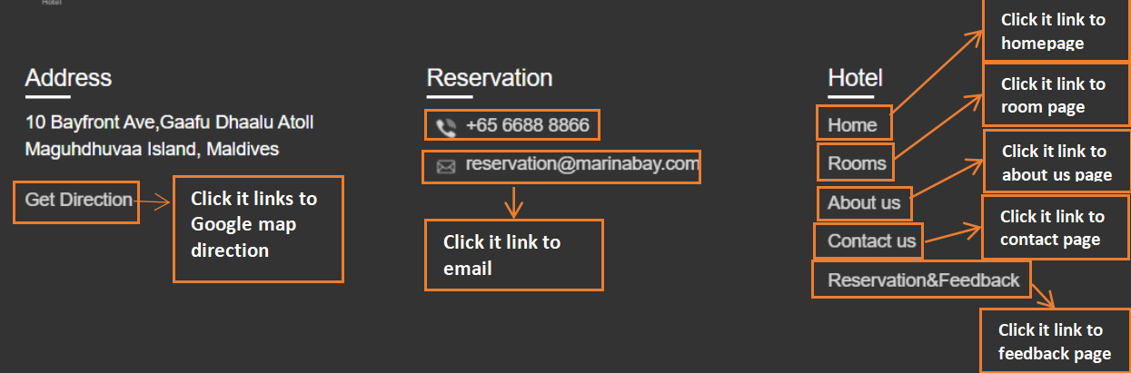

***Figure 2.1.3.1 Footer Navigation Menu***

*Figure 2.1.3.1 shows the navigation menu for customers and some contact details of hotel*

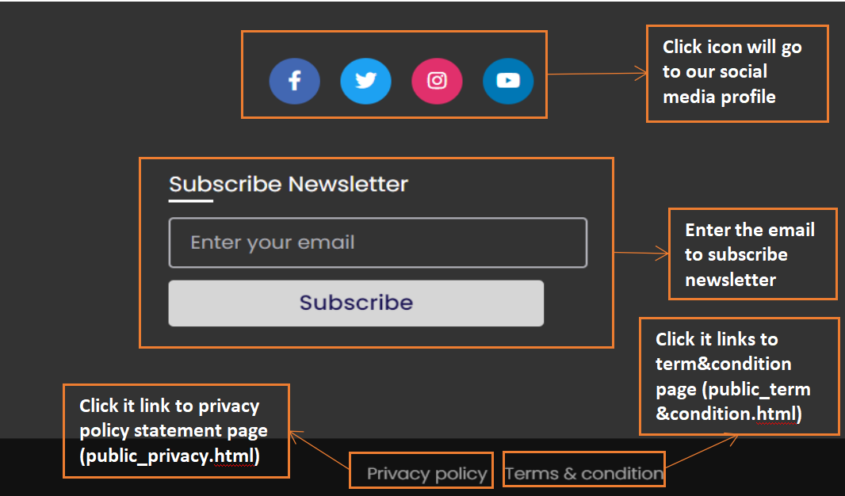

***Figure 2.1.3.2 Footer Navigation Menu***

*Figure 2.1.3.2 shows the navigation icons for customers and customers can click it to view the hotel's social media profile. Customers also can subscribe to the newsletter by entering their email address.*

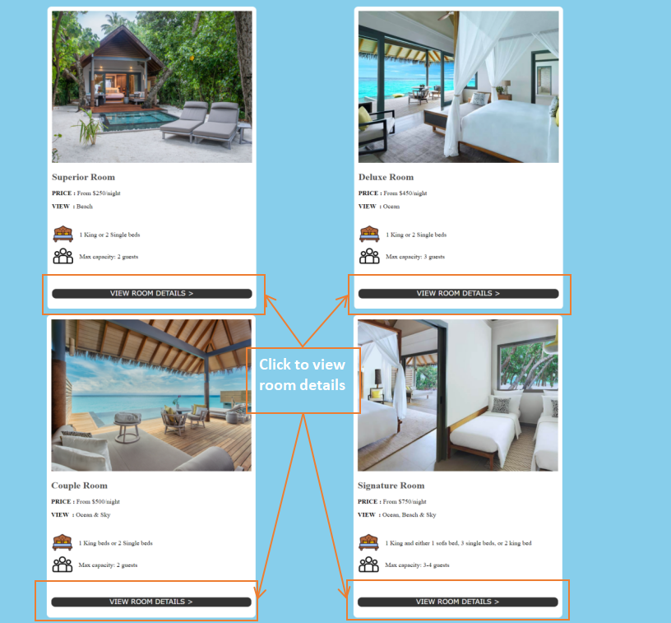

***Figure 2.1.4 Room Page***

*Figure 2.1.4 shows all the rooms that the hotel provided and customers can view the details of each room by clicking “VIEW ROOM DETAILS”.*

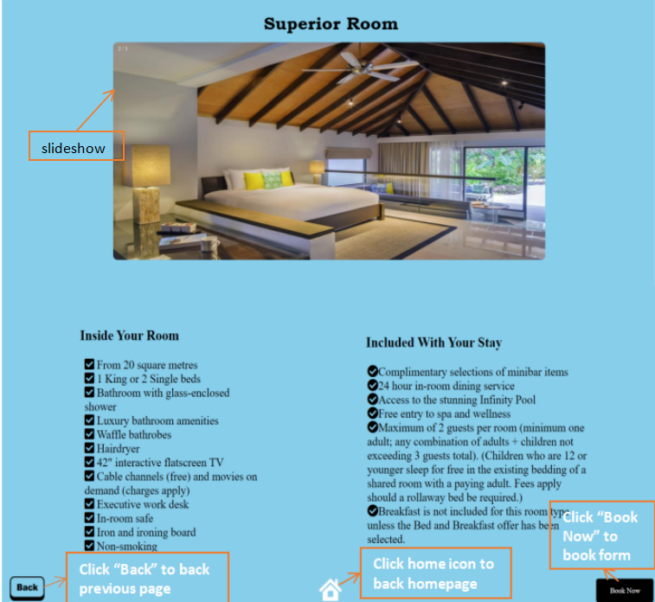

***Figure 2.1.5.1 Superior Room***

*Figure 2.1.5.1**shows the Superior Room’s details that are provided and the photo of the room is shown as slideshow design. Customers can book this room by clicking the “Book Now”.*

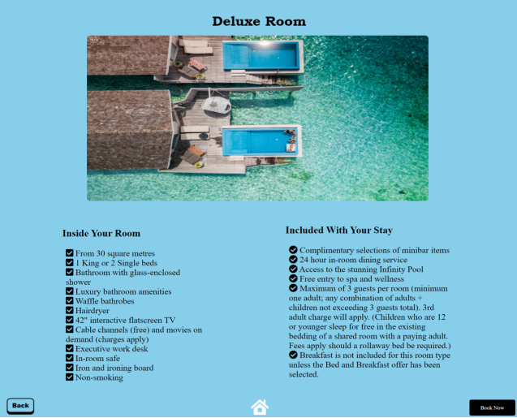

***Figure 2.1.5.2 Deluxe Room***

*Figure 2.1.5.2**shows the Deluxe Room’s details that are provided and the photo of the room is shown as slideshow design. Customers can book this room by clicking the “Book Now”.*

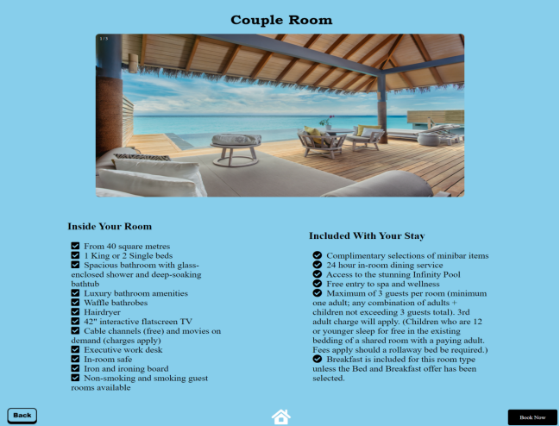

***Figure 2.1.5.3 Couple Room***

*Figure 2.1.5.3**shows the Couple Room’s details that are provided and the photo of the room is shown as slideshow design. Customers can book this room by clicking the “Book Now”.*

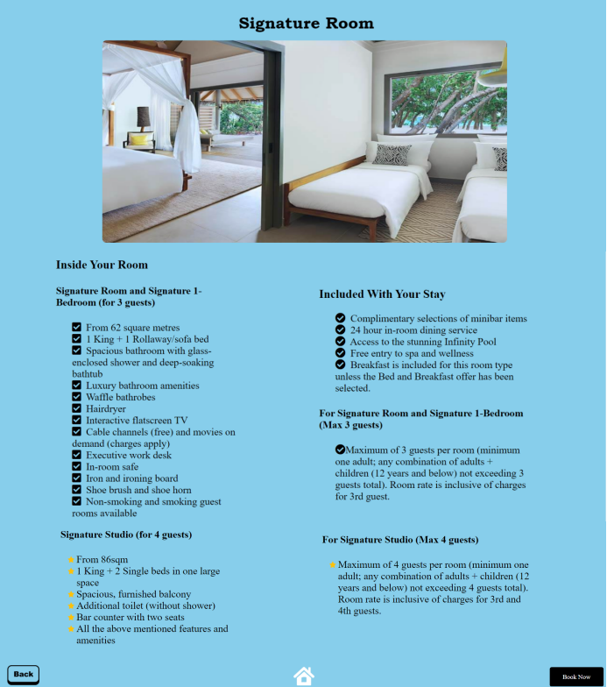

***Figure 2.1.5.4 Signature Room***

*Figure 2.1.5.4**shows the Signature Room’s details that are provided and the photo of the room is shown as slideshow design. Customers can book this room by clicking the “Book Now”.*

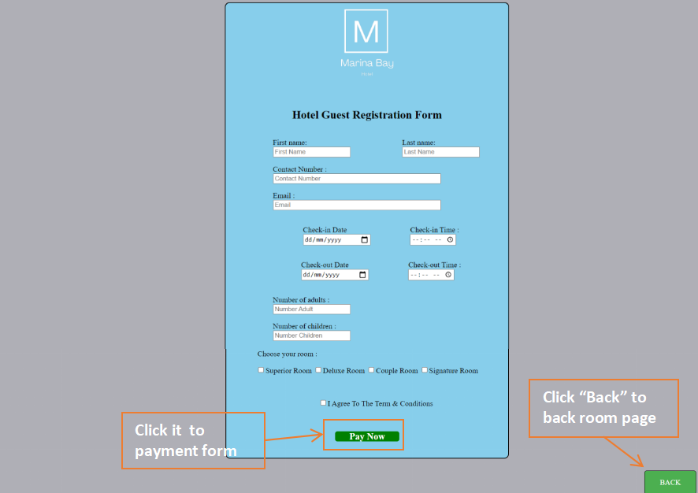

***Figure 2.1.6 Hotel Guest Registration Form***

*Figure 2.1.6**shows the booking form after the customer clicks the “Book Now” button and the customer needs to fill in the details for booking purposes. After that, click “Pay Now” to pay the fees for the booking room.*

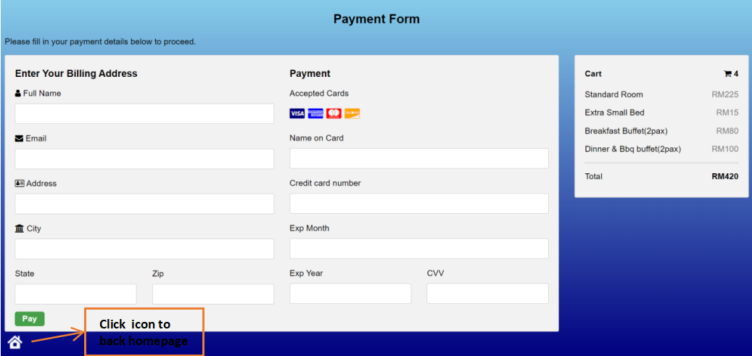

***Figure 2.1.7 Payment Form***

*Figure 2.1.7**shows the payment form after the customer clicks the “Pay Now” button and the customer needs to fill in the details for the payment card to make a payment. After that, click the “Pay” to pay.*

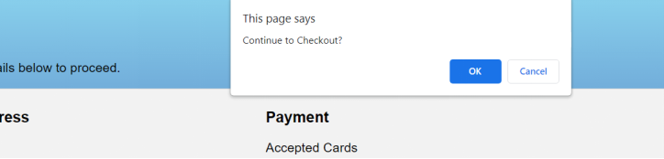

***Figure 2.1.7.1 Payment Form***

*Figure 2.1.7.1**shows the confirmation of payment after the customer clicks the “Pay” button. Customers click “OK” to confirm payment.*

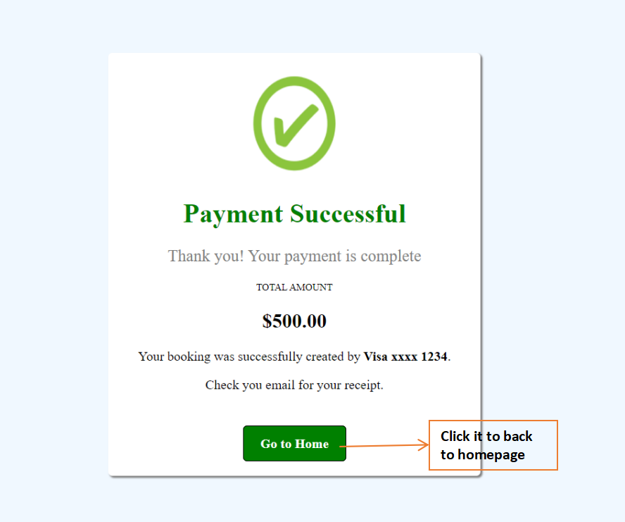

***Figure 2.1.8 Successful Payment Page***

*Figure 2.1.8**shows the success of payment after the customer confirms the payment. Customer can click “Go to Home” to back homepage*

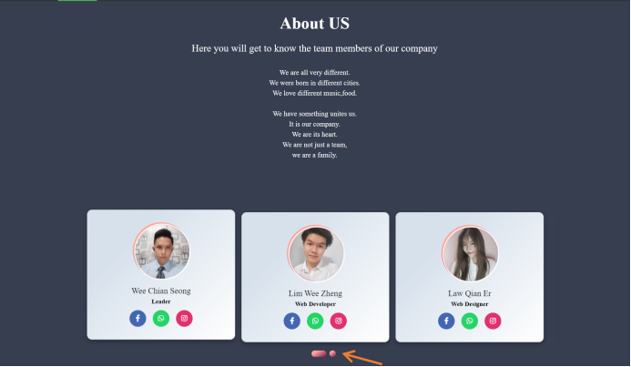

***Figure 2.1.9 About Us Page***

*Figure 2.1.9**shows the about us page which is all the staff of the hotel. The icon can be clicked to view each of staffs’ social media such as Facebook,WhatsApp and Instagram. Customers can click the circle button to view other staff.*

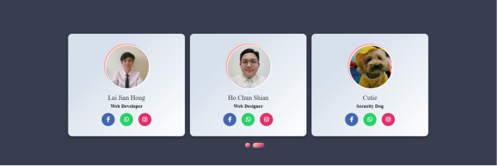

***Figure 2.1.9.1 About Us Page***

*Figure 2.1.9.1**shows other staff when customers click the circle button.*

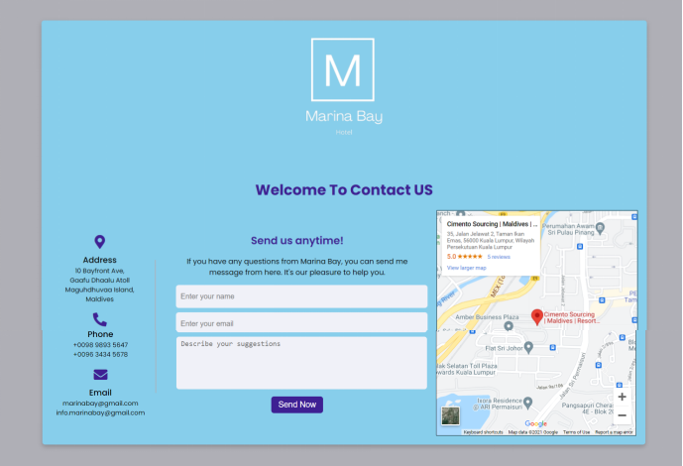

***Figure 2.1.10 Contact Us Page***

*Figure 2.1.10 shows all the contact details of the hotel and the direction of Hotel. Customers can ask questions by filling in the details and clicking “Send Now” to send questions.*

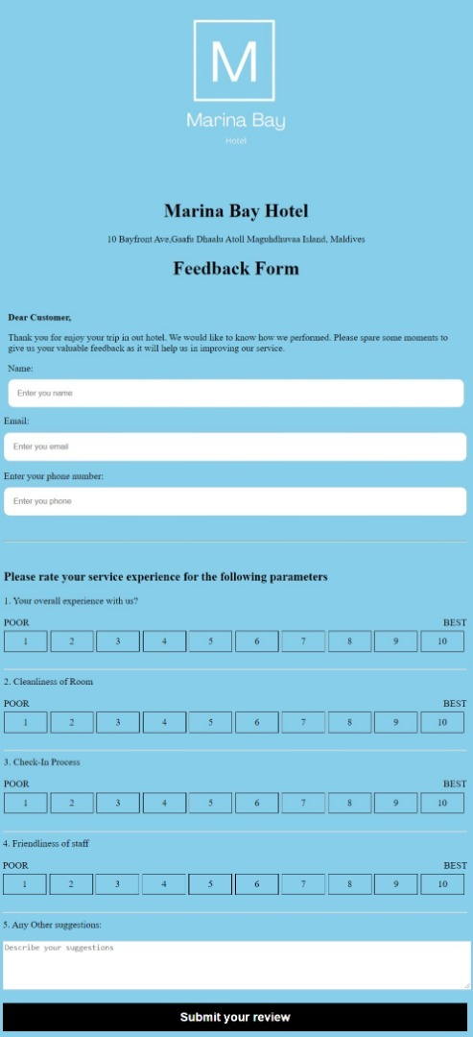

***Figure 2.1.11 Feedback Form***

*Figure 2.1.11 shows the feedback form of customers that customers can fill in their review after experiencing the hotel. This form can be accessed by clicking the “Reservation & Feedback” at the footer.*

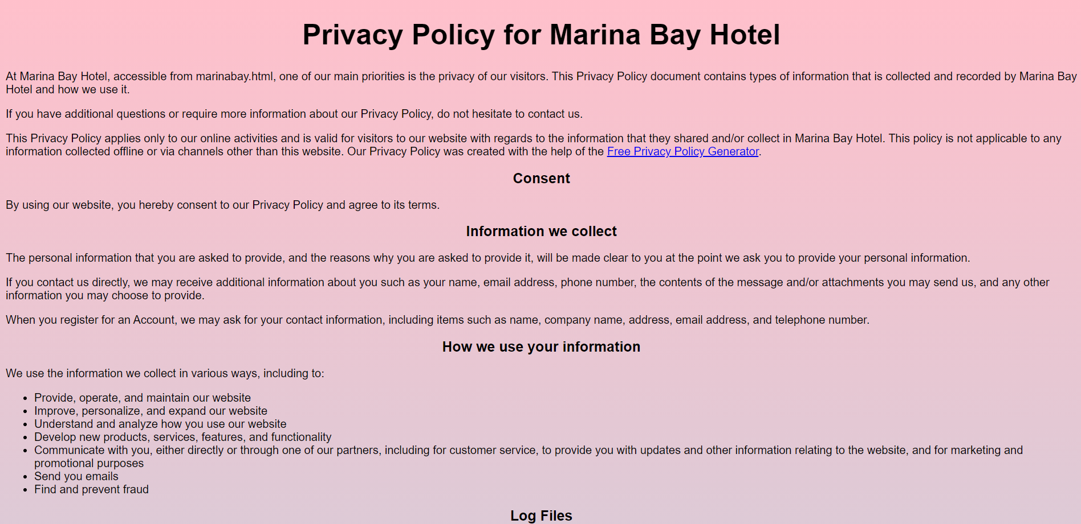

***Figure 2.1.12 Privacy Policy of Hotel***

*Figure 2.1.12 shows the privacy policy of the hotel when using this website. This page can be accessed by clicking the “Privacy policy” at the right bottom of the footer.*

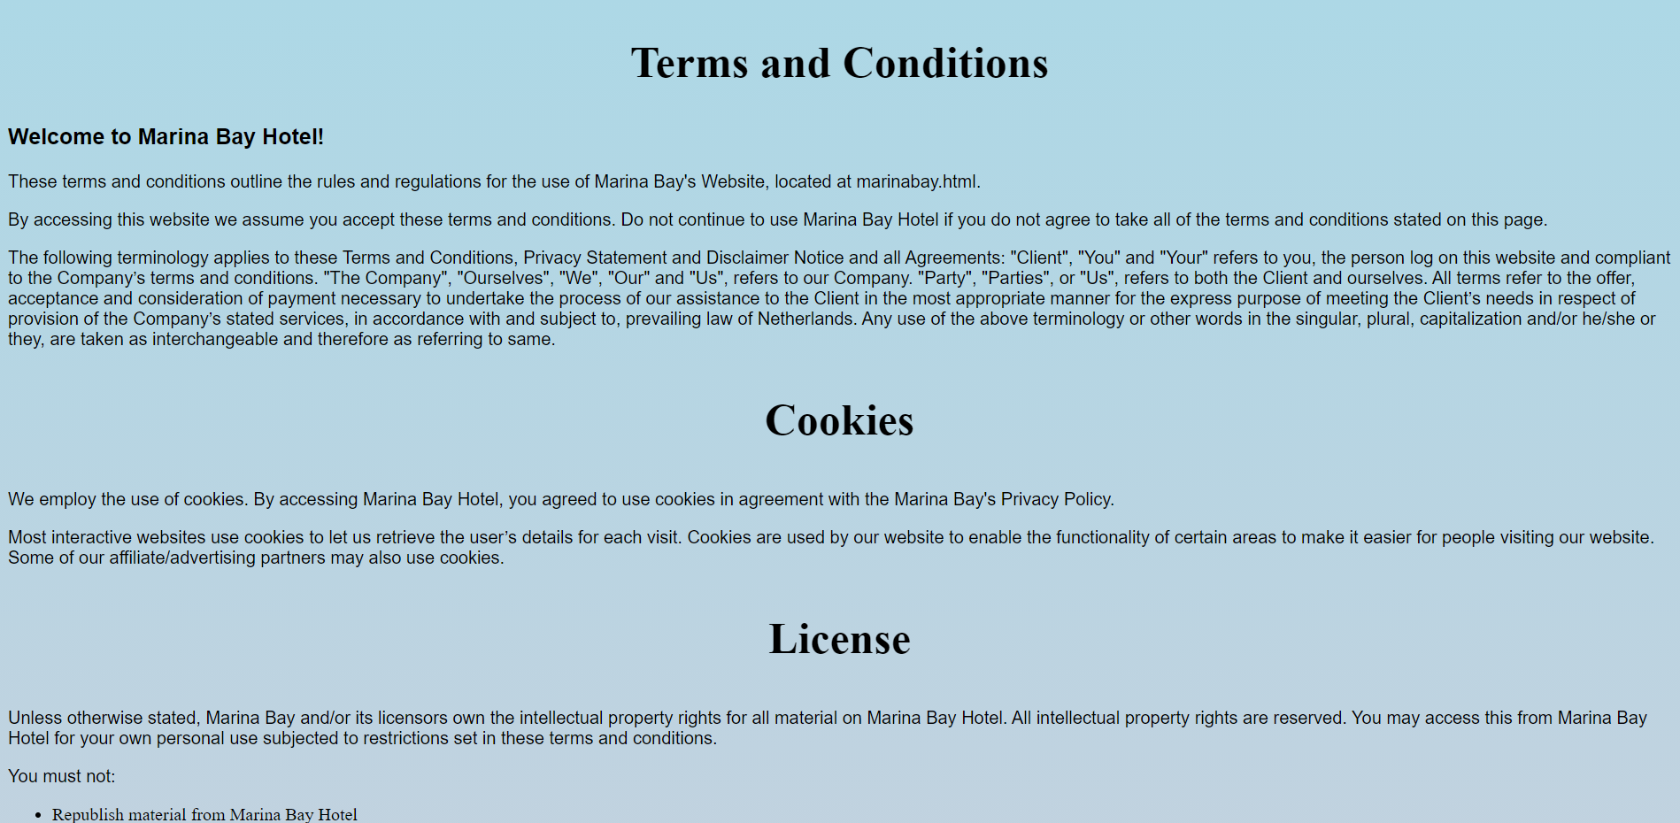

***Figure 2.1.13 Terms and Conditions of Hotel***

*Figure 2.1.13 shows the terms and conditions of the hotel when using this website. This page can be accessed by clicking the “Terms & condition” at the right bottom of the footer.*

**2.2 User**

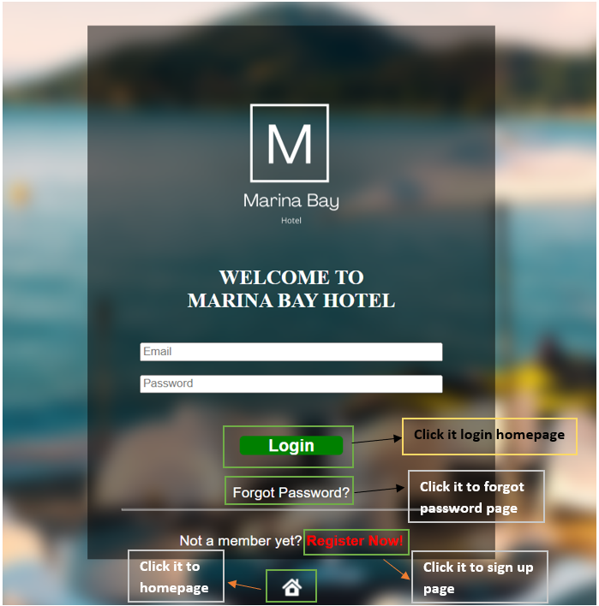

***Figure 2.2.1 Hotel Login Page***

*Figure 2.2.1 shows the hotel login page for the users login to our website. After the users enter their email and password, they can click the “Login” button to login. If don't have a login account, they can click the “Register Now” button to register a new account.*

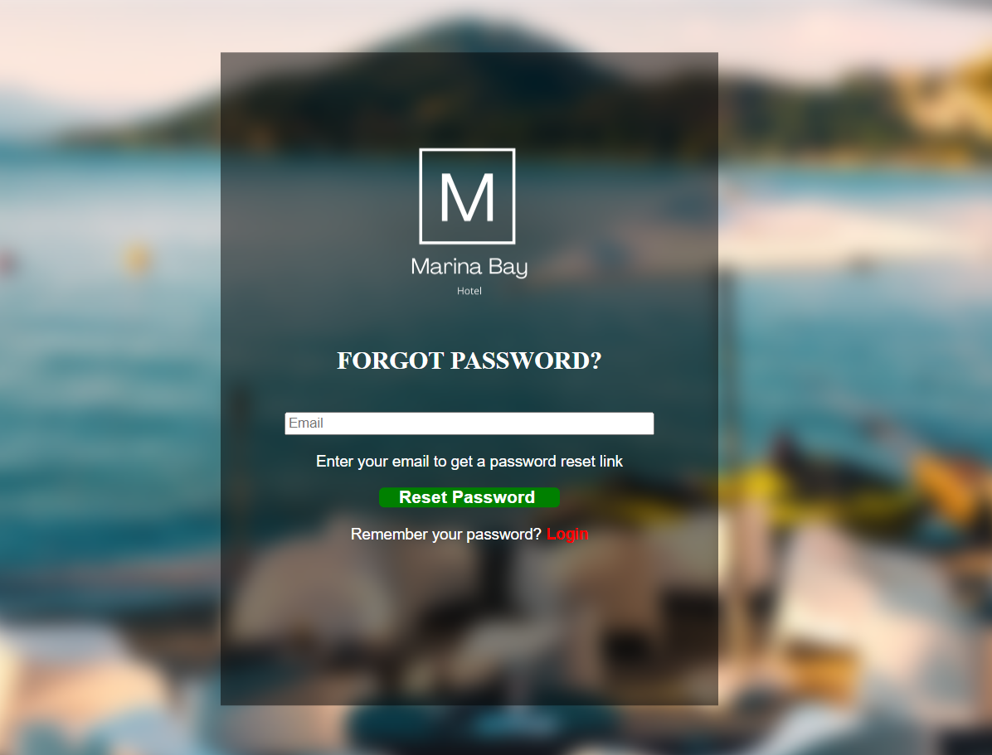

***Figure 2.2.2 Forgot Password Page***

*Figure 2.2.2 shows the forgot password page after users click the “Forget Password?”. Users need to enter their email address, then click” Reset Password” to continue.*

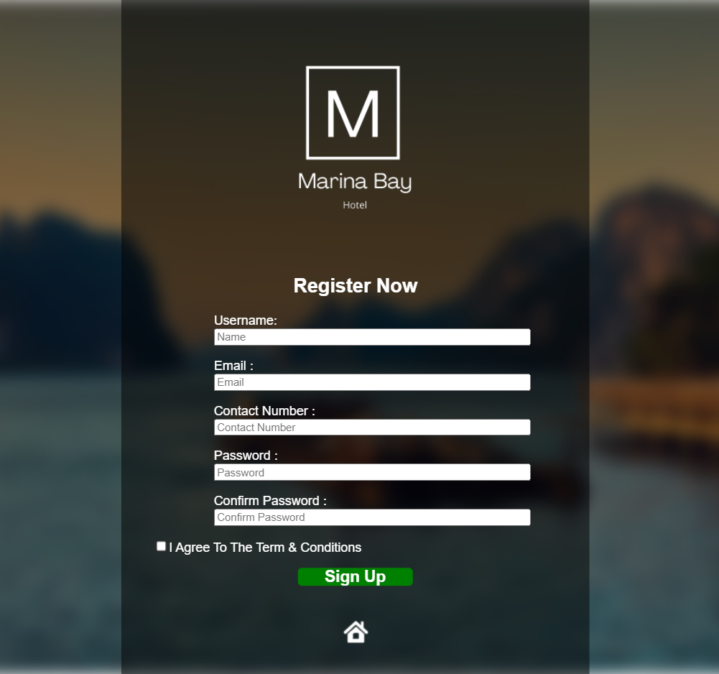

***Figure 2.2.3 Hotel Sign In Page***

*Figure 2.2.3 shows the register form for users. If the user hasn't register, they need to fill in their personal information to sign up.*

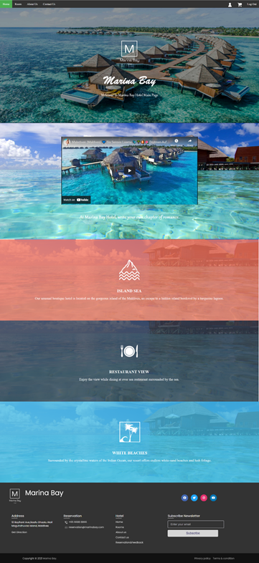

***Figure 2.2.4 User Home Page***

*Figure 2.2.4**shows the design of the user homepage to attract user’s view.*

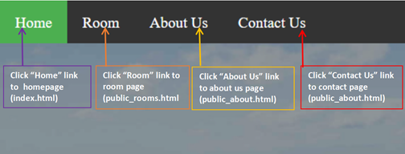

***Figure 2.2.5 Left-side Header Navigation Bar***

*Figure 2.2.5 shows the left-side header navigation bar that provides access links to other pages by clicking the menu item.*

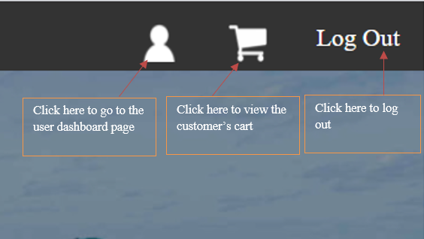

***Figure 2.2.6 Right-side Header Navigation Bar***

*Figure 2.2.6 shows the right-side header navigation bar that provides access links to other pages by clicking the menu item.*

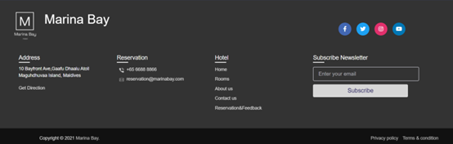

***Figure 2.2.7 Footer Navigation Menu***

*Figure 2.2.7 shows the bottom navigation menu that provide access link to other pages by click the menu item*

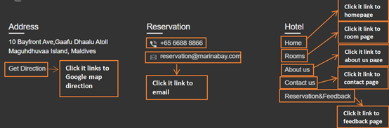

***Figure 2.2.8 Footer Navigation Menu***

*Figure 2.2.8 shows the navigation menu for customers and some contact details of the hotel.*

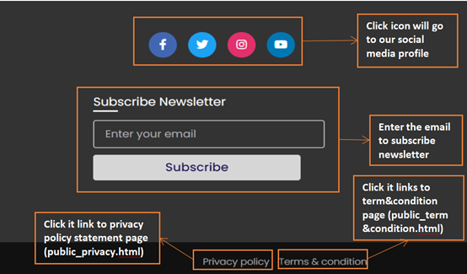

***Figure 2.2.9 Footer Navigation Menu***

*Figure 2.2.9 shows the navigation icons for customers and customers can click it to view the hotel's social media profile. Customer also can subscribe to the newsletter by entering their email address.*



***Figure 2.2.10 Hotel Room List Page***

*Figure 2.2.10 shows the hotel room in the list when the user wants to book a room. Users can click “VIEW ROOM DETAILS” to see more details for each room.*

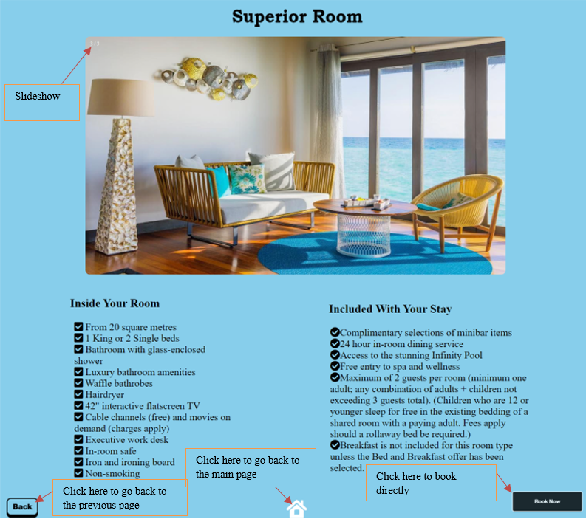

***Figure 2.2.11 Superior Room Page***

*Figure 2.2.11 shows the Superior Room when the user chooses this type of room and the photo of the room is shown as a slideshow design. After that, users can click the “Book Now” button to do their booking. If the user wants to go back to the hotel room list page or home page, they can click on the “Back” button and “Home” icon button.*

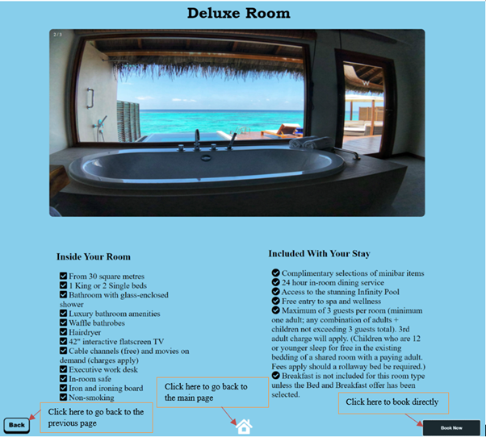

***Figure 2.2.12 Deluxe Room Page***

Figure 2.2.12 shows the details and information of our hotel Deluxe Room. It can also directly book the room in this page.

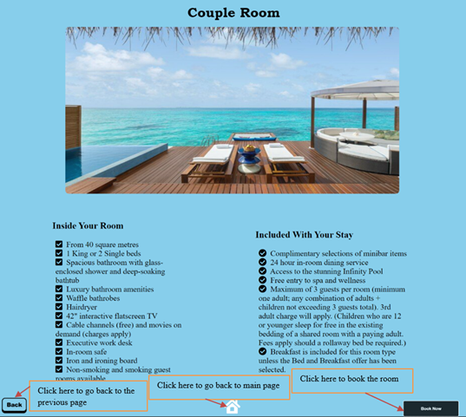

***Figure 2.2.13 Couple Room Page***

Figure 2.2.13 shows the details and information of our hotel Couple Room. It can also directly book the room in this page.

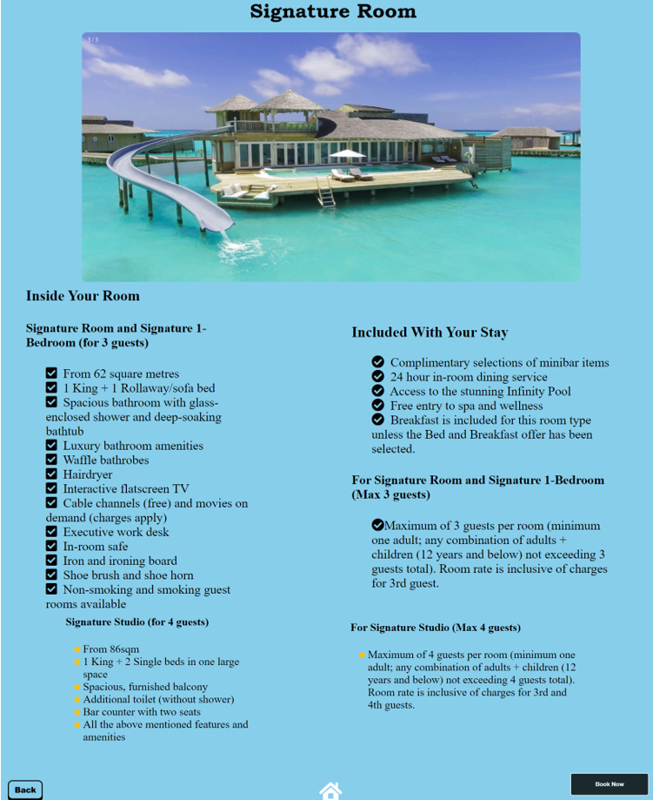

***Figure 2.2.14 Signature Room Page***

Figure 2.2.14 shows the Signature Room when the user chooses this type of room. After that, users can click the “Book Now” button to do their booking.

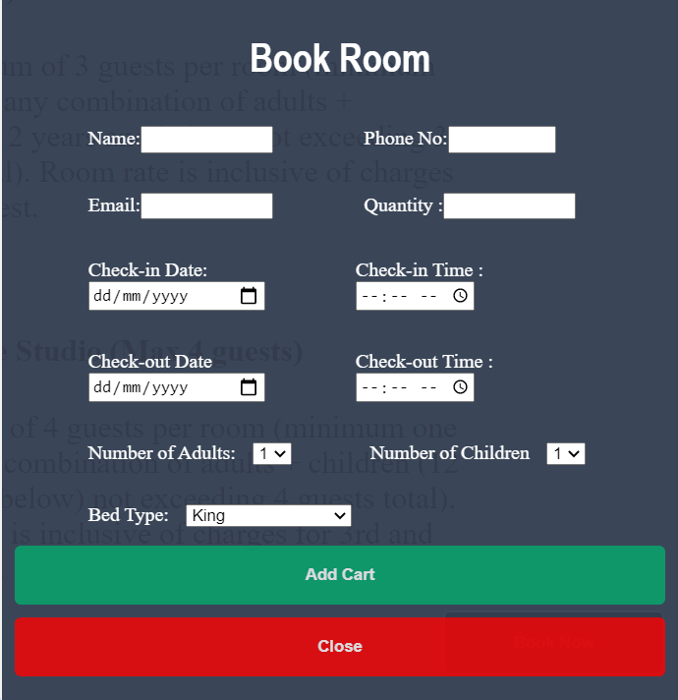

***Figure 2.2.15 Pop-Up Book Form***

*Figure 2.2.15 shows the hotel registration detail when the user wants after the customer clicks the “Book Now” button and the customer needs to fill in the details for booking purposes. After that, click “Pay Now” to pay the fees for the booking room.*

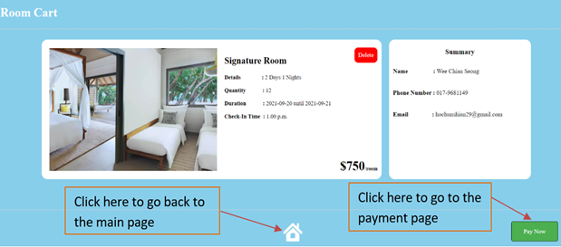

***Figure 2.2.16 User Room Cart***

*Figure 2.2.16 shows the customer’s cart after the customer has chosen which room they want to stay in. Customers can click ‘Pay Now’ to go to the payment page or click the home button to go back to the main page.*

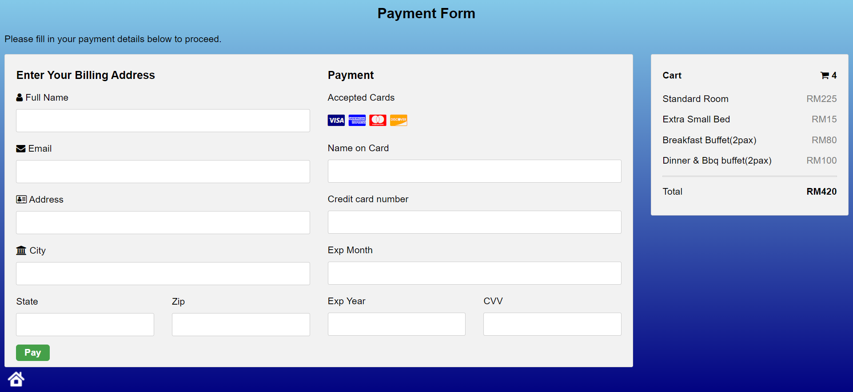

***Figure 2.2.17 User Payment Page***

*Figure 2.1.17 shows the payment form after the customer clicks the “Pay Now” button and the customer needs to fill in the details for the payment card to make a payment. After that, click the “Pay” to pay.*

**

***Figure 2.2.18 Payment Form***

*Figure 2.2.18**shows the confirmation of payment after the customer clicks the “Pay” button. Customers click “OK” to confirm payment.*

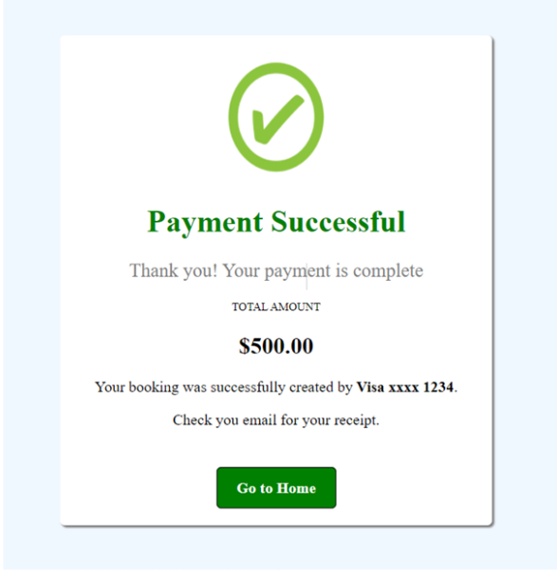

***Figure 2.2.19 payment successful page***

*Figure 2.2.19 shows the payment successful page when the users successfully do their payment. Users also can click the “Go to Home” button to the home page.*

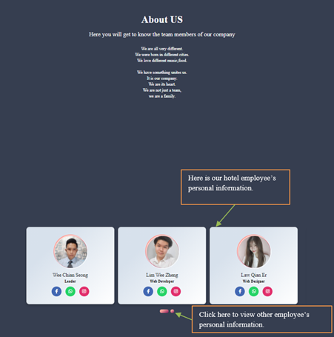

***Figure 2.2.20 About us Page***

*Figure 2.2.20 shows our hotel employee’s personal information, and customers can contact them through their social media.*

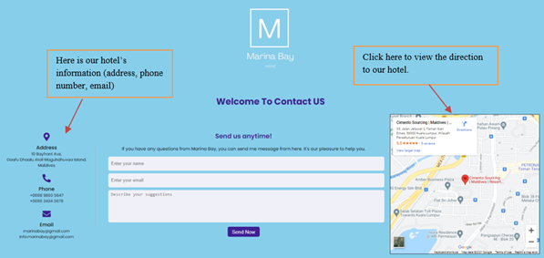

***Figure 2.2.21 Contact Us Page***

*Figure 2.2.21 shows that there is a map to get the direction to our hotel. Users can get the actual address, phone number, and email.*

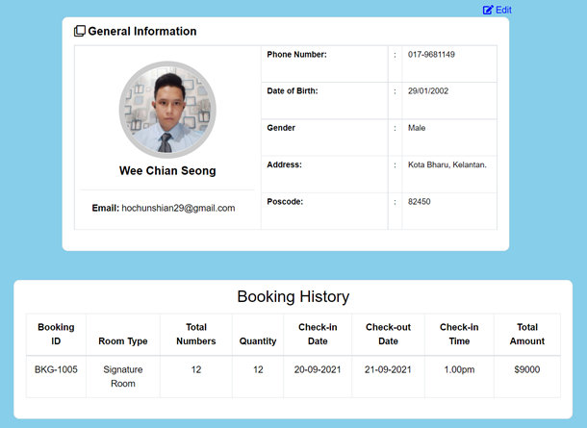

**Figure 2.2.22 Dashboard Page**

Figure 2.1.22 shows Dashboard Page which can view user information details and booking history.

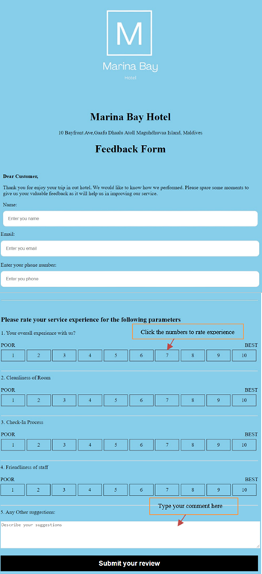

***Figure 2.2.23 User Comment & Rating***

*Figure 2.2.23 shows that customers can give their rating to our service and write any comments about our services at the comment box.*

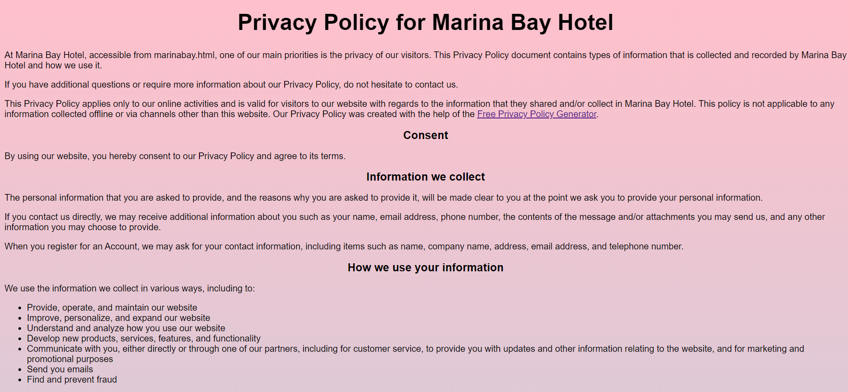

***Figure 2.2.24 Marina Bay Hotel Privacy and Policy Page***

*Figure 2.2.24 shows the privacy policy of the hotel when using this website. This page can be accessed by clicking the “Privacy policy” at the right bottom of the footer.*

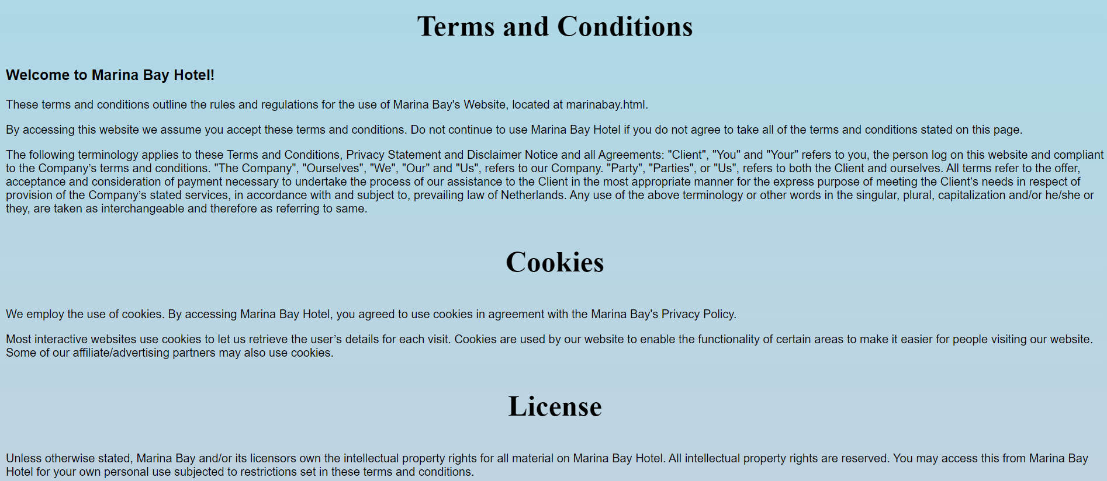

***Figure 2.2.25 Term and Condition Page***

*Figure 2.2.25 shows the terms and conditions of the hotel when using this website. This page can be accessed by clicking the “Terms & condition” at the right bottom of the footer.*

**Admin**

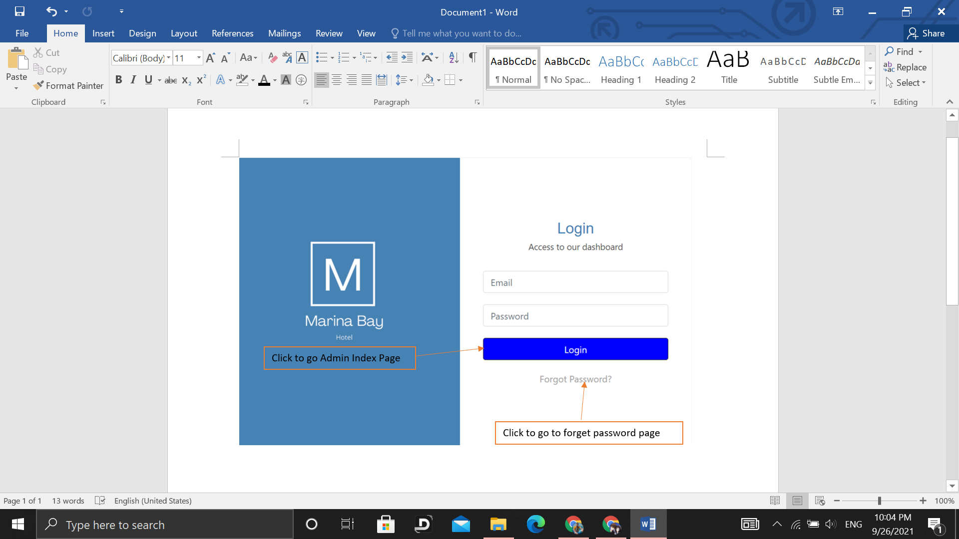

***Figure 2.3.1 Admin Login Page***

*Figure 2.2.1 shows the admin login page. Admin Login Page has two components. The Login button links to the Admin Index Page. The Forgot Password link to the Forgot Password Page.*

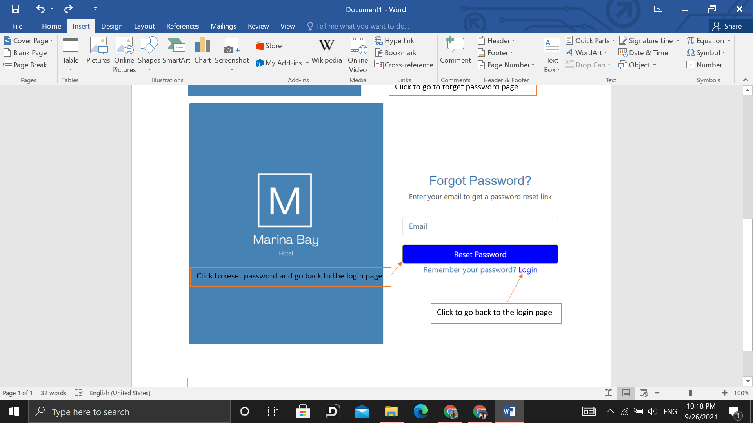

***Figure 2.3.2 Forgot Password Page***

*Figure 2.2.2 shows the Forgot Password Page which contains two components. One is the Reset Password button used to reset and direct go back to the Admin Login Page. The Login hyperlink is linked to the Login Page.*

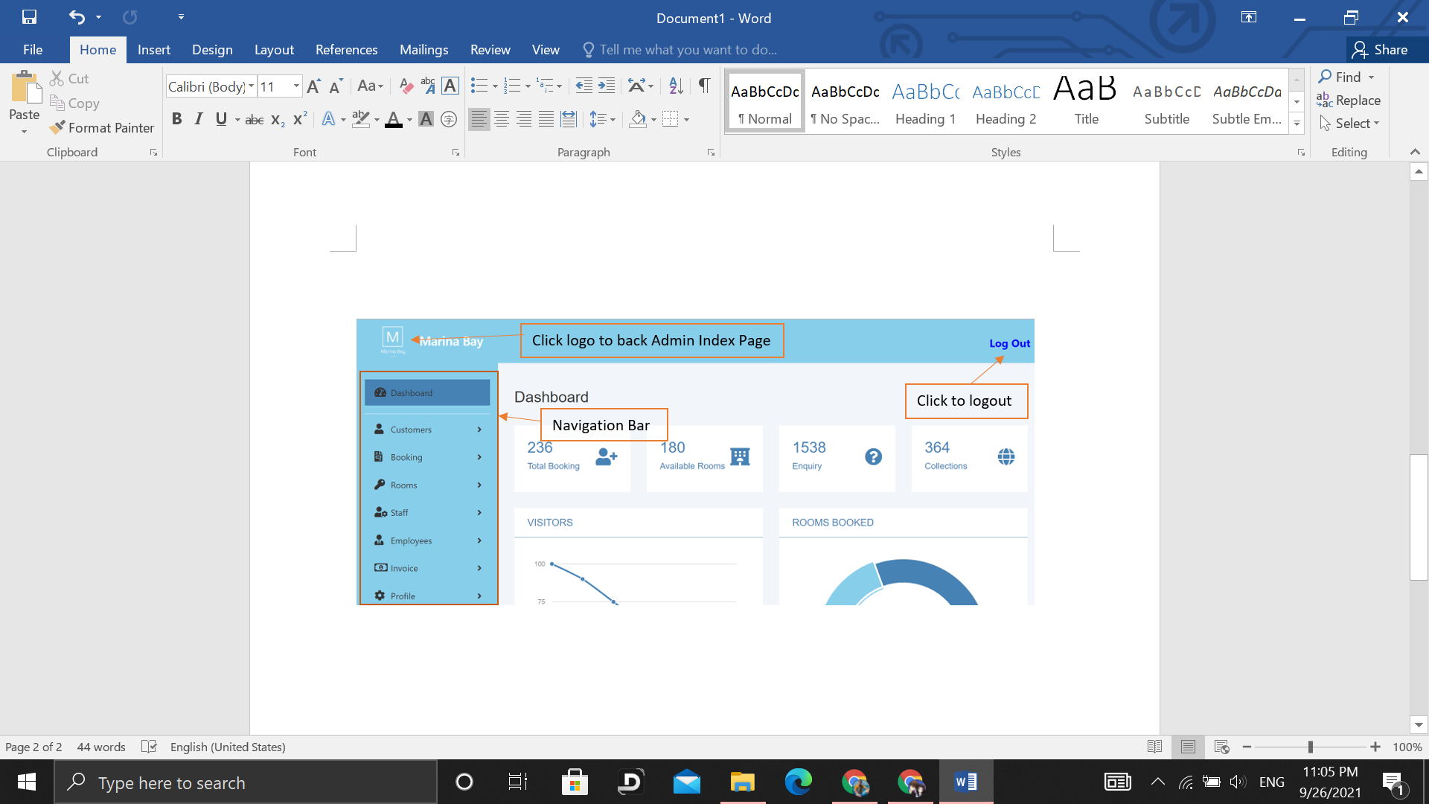

***Figure 2.3.3.1 Admin Index Page***

*Figure 2.2.3.1 shows the admin page which contains 3 components. Logo can be clicked to go back to the Admin Index Page. Navigation bar can be clicked to link into each section to edit,add or delete.Logout click to logout from admin.*

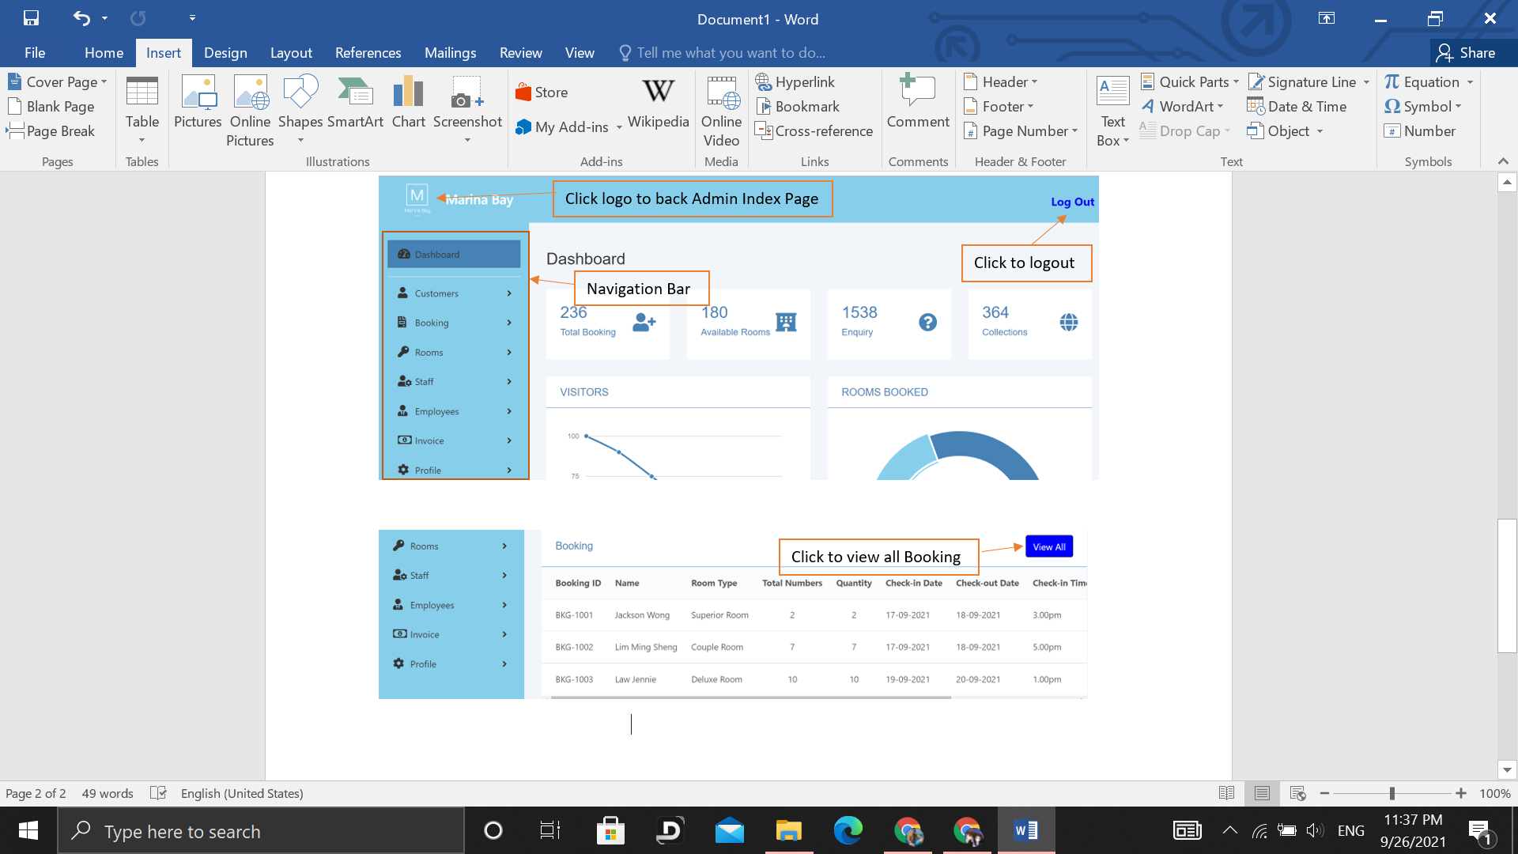

***Figure 2.3.3.2 Below Part of Admin Index Page***

*Figure 2.2.3.2 shows the below part of the admin index page. There is a button that can be clicked to View Booking Details Page.*

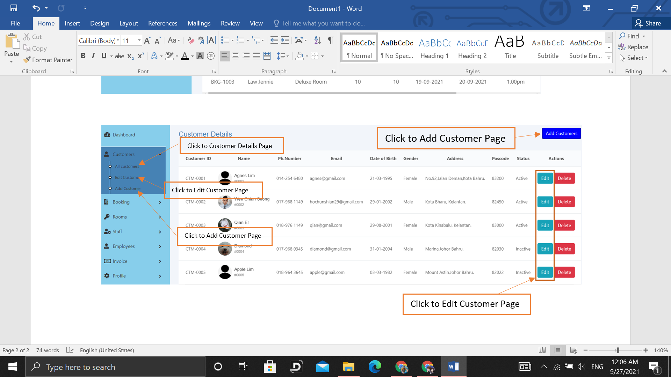

***Figure 2.3.4 Customer Details Page***

*Figure 2.2.4 shows the customer details page. At the left side navigation click All Customer will link to the Customer Details Page. Click Edit Customer and Edit Button will link to Edit Customer Page. Click Add Customer and Add Customers Button will link to Add Customer Page.*

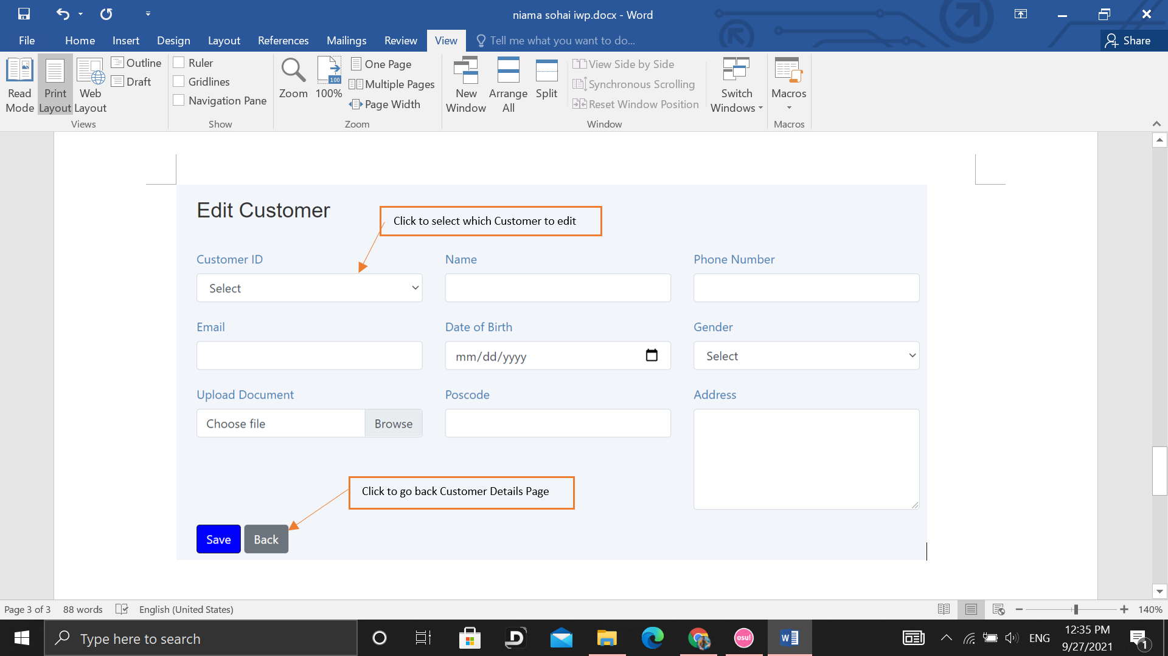

***Figure 2.3.5 Edit Customer Page***

*Figure 2.3.5 shows the Edit Customer Page which contains a form to edit and 2 buttons. Click the Back button to go back to the Customer Details page. Click select to select the Customer ID u want to edit.*

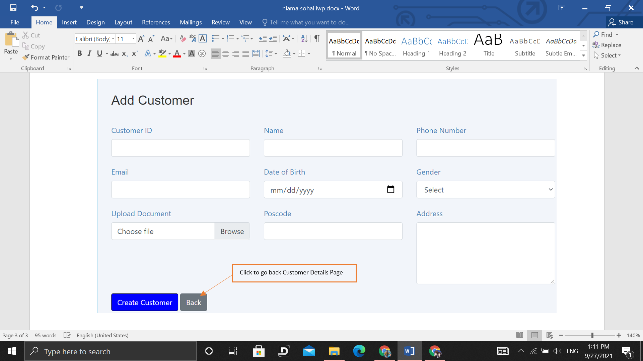

***Figure 2.3.6 Add Customer Page***

*Figure 2.3.6 shows the Add Customer Page(add-customer.html). Click the Back button to back to the Customer Details Page(all-customers.html).*

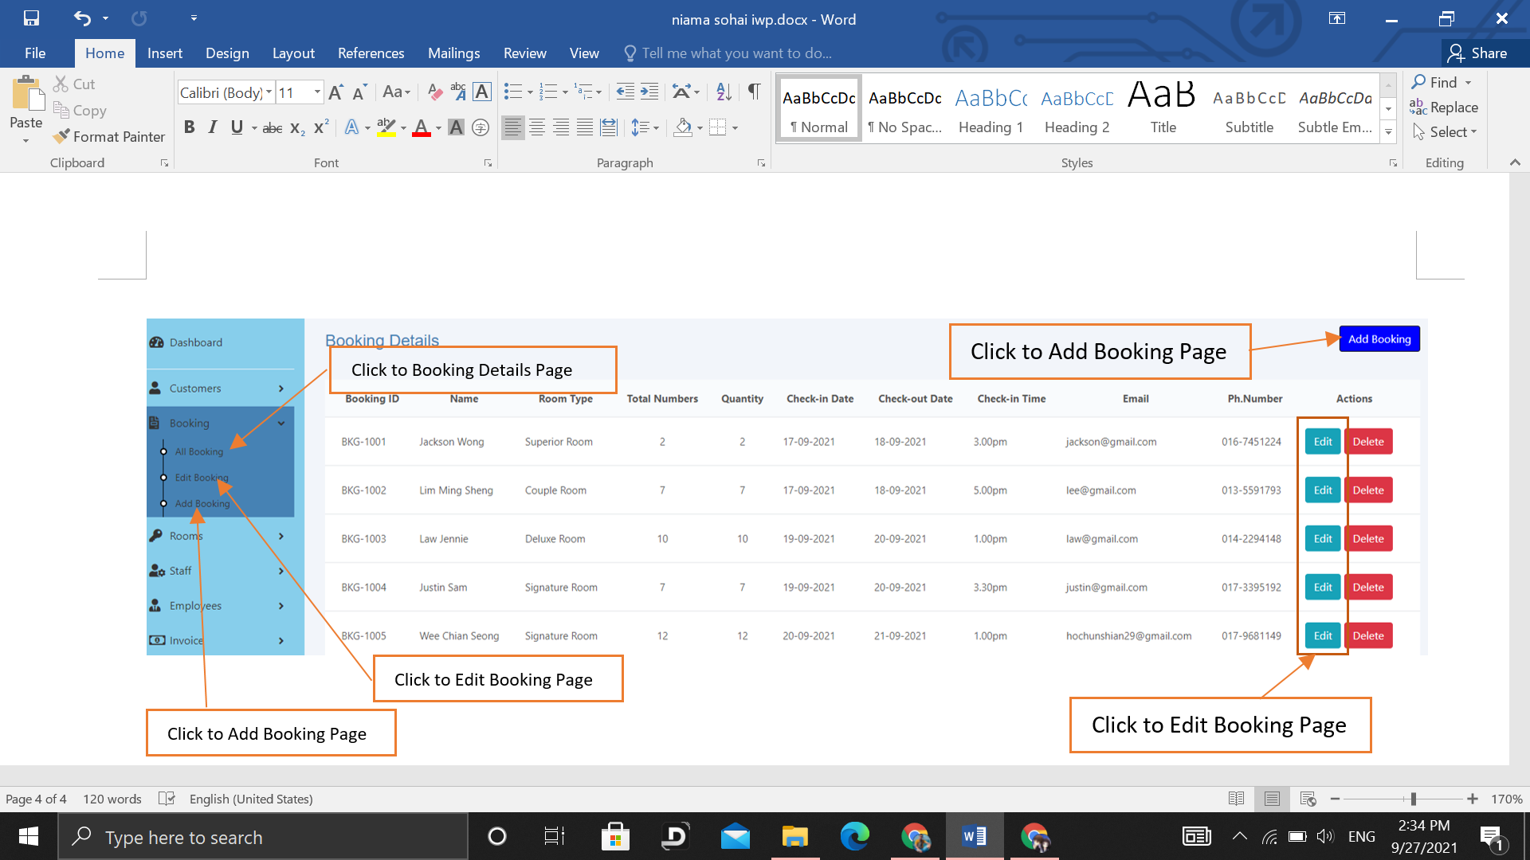

***Figure 2.3.7 Booking Details Page***

*Figure 2.3.7 shows the Booking Details Page. At the left side navigation click All Booking will link to the Booking Details Page. Click Edit Booking and Edit Button will link to Edit Booking Page. Click Add Booking and Add Booking Button will link to Add Booking Page.*

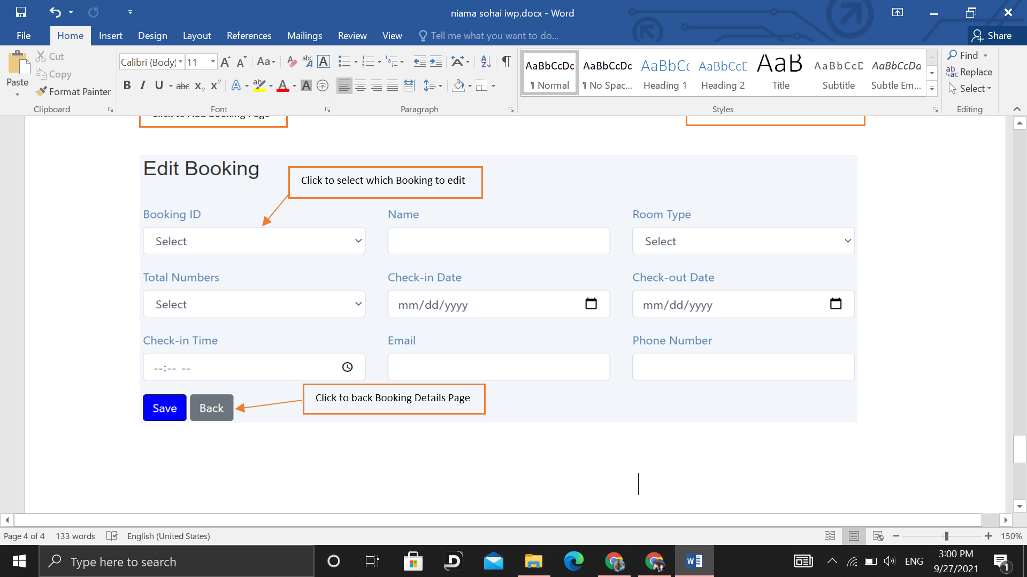

***Figure 2.3.8 Edit Booking Page***

*Figure 2.3.8 shows the Edit Booking Page. Click Back Button to go back to the Booking Details Page.*

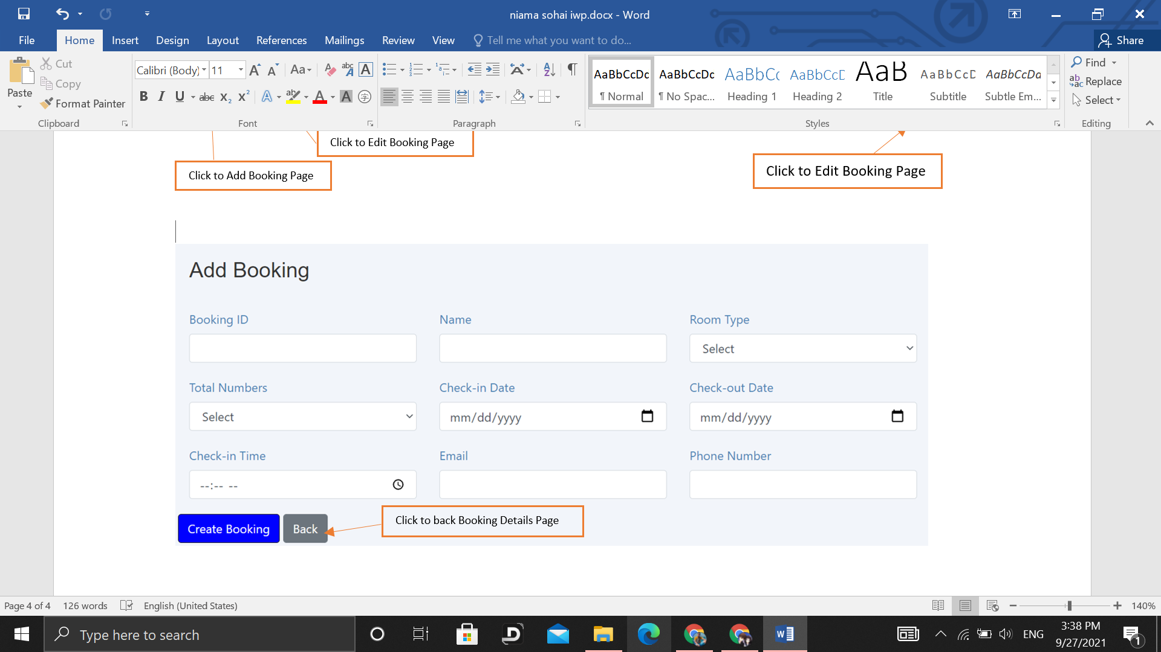

***Figure 2.3.9 Add Booking Page***

*Figure 2.3.9 shows Add Booking Page. There is a Back Button click to link back to the Booking Details page.*

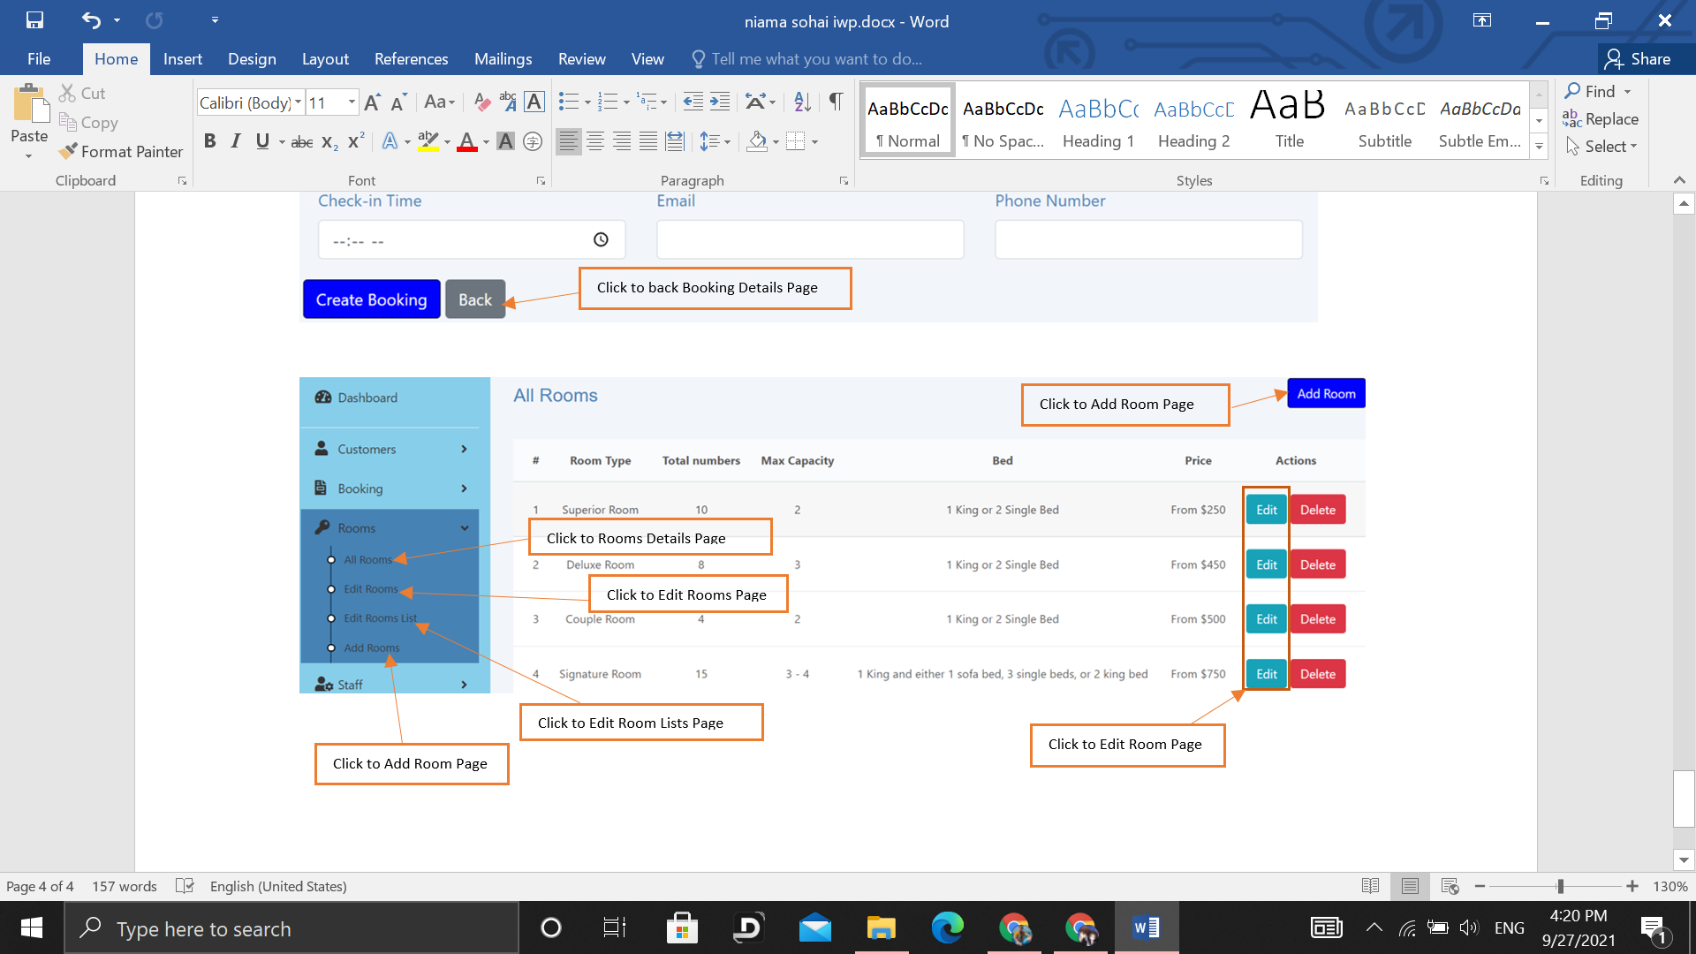

***Figure 2.3.10 Rooms Details Page***

*Figure 2.3.10 shows the Rooms Details Page. At the left side navigation click All Rooms will link to the Room Details Page. Click Edit Rooms and Edit Button will link to the Edit Room Page. Click Edit Room Lists to the Edit Room List Page. Click Add Room and Add Room Button will link to Add Room Page.*

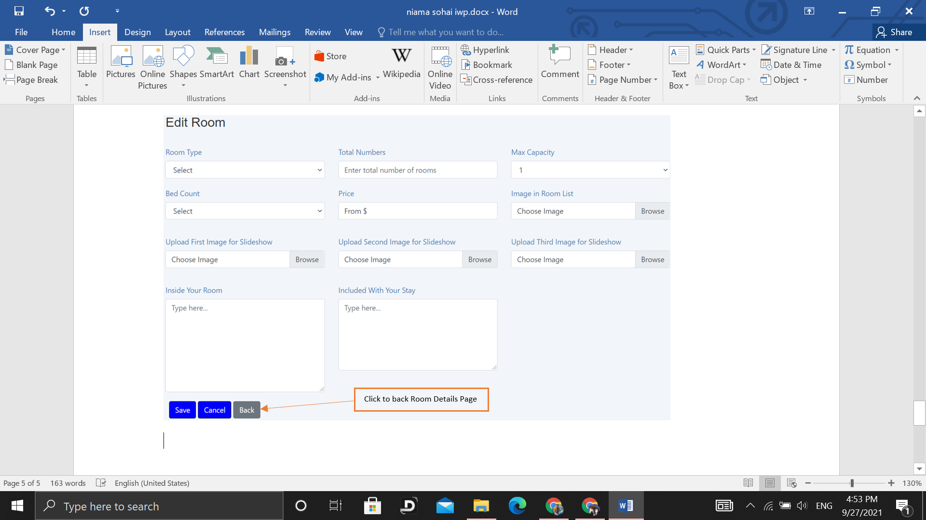

***Figure 2.3.11 Edit Room Page***

*Figure 2.3.11 shows the Edit Room Page. Click the Back Button back to the Room Details Page.*

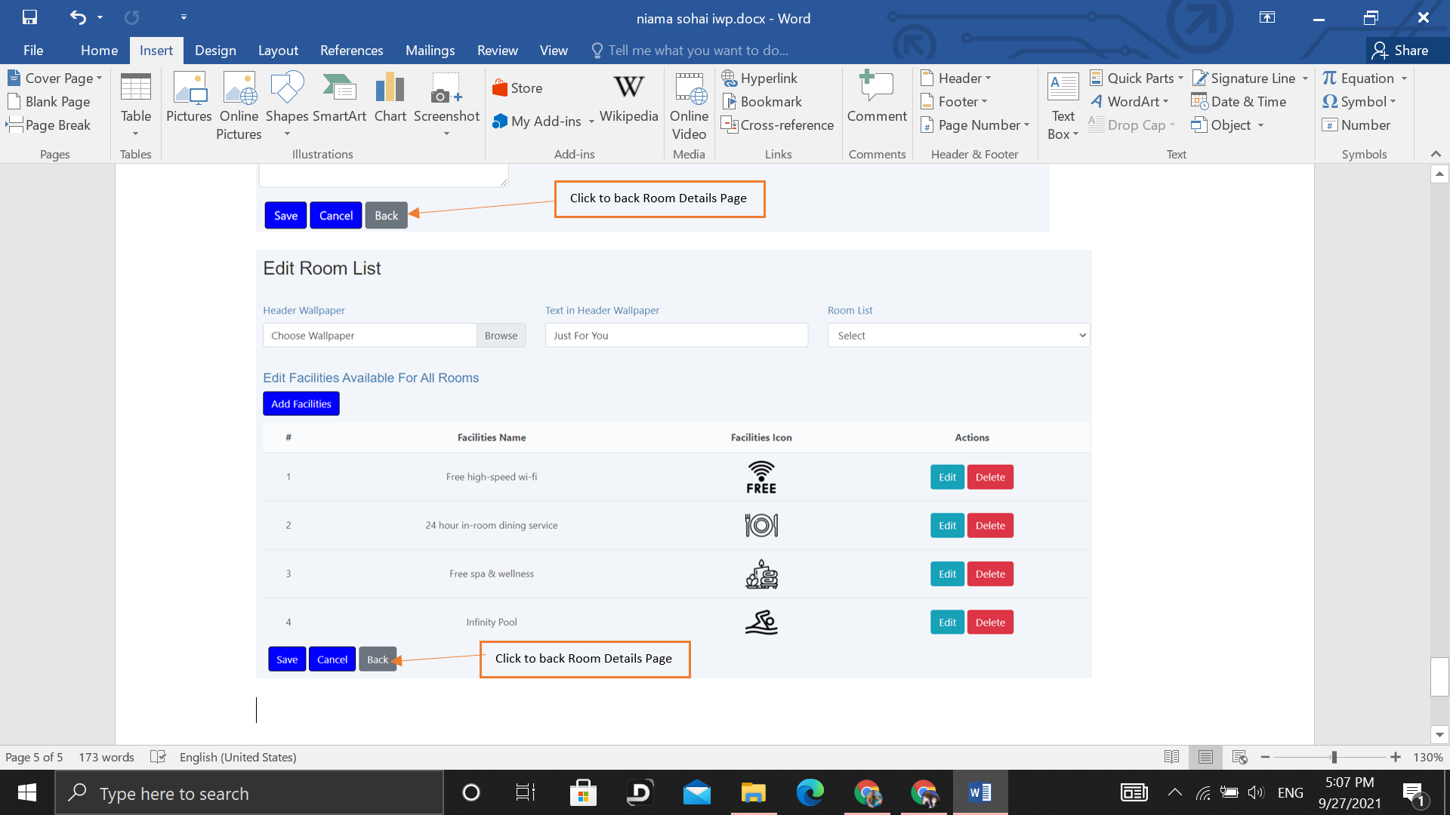

***Figure 2.3.12 Edit Room List Page***

*Figure 2.3.12 shows the Edit Room List Page. Click the Back Button to Room Details Page.*

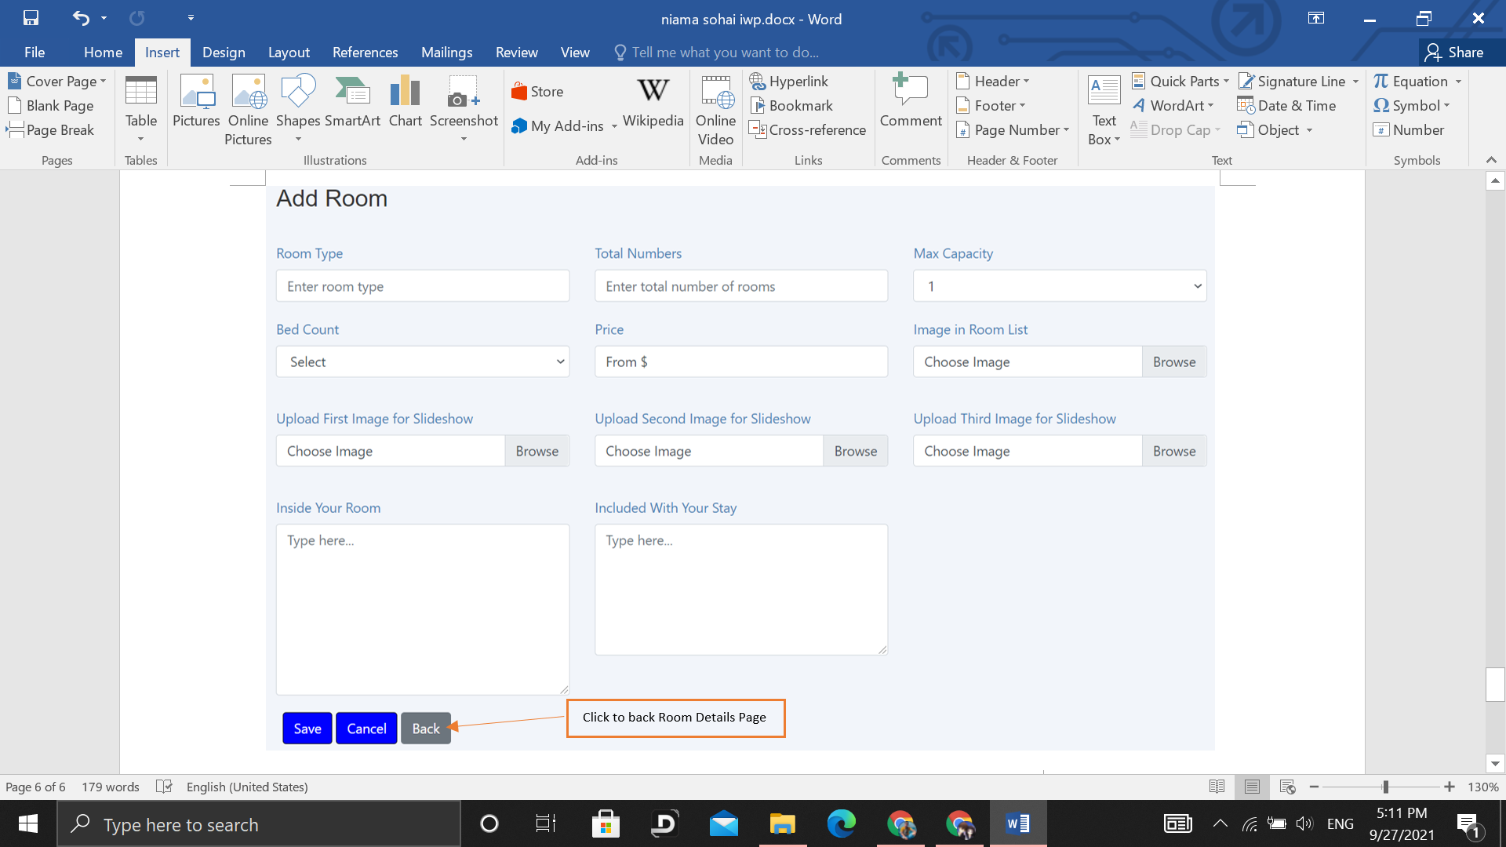

***Figure 2.3.13 Add Room Page***

*Figure 2.3.13 shows the Add Room Page. Click the Back Button to Room Details Page.*

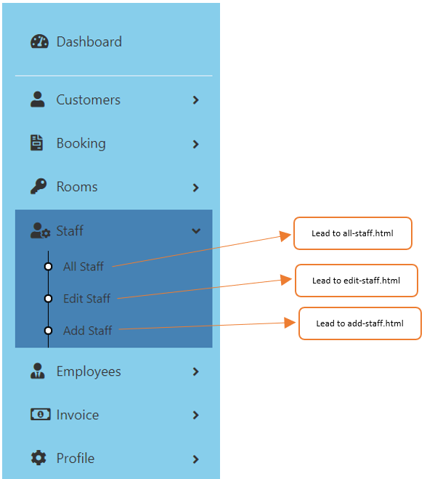

***Figure 2.3.14: Staff in Navigation Bar***

*Figure 2.3.14 shows the pop-down list of “Staff” in the navigation bar. The three bullet lists can lead to all-staff.html, edit-staff.html, add-staff.html.*

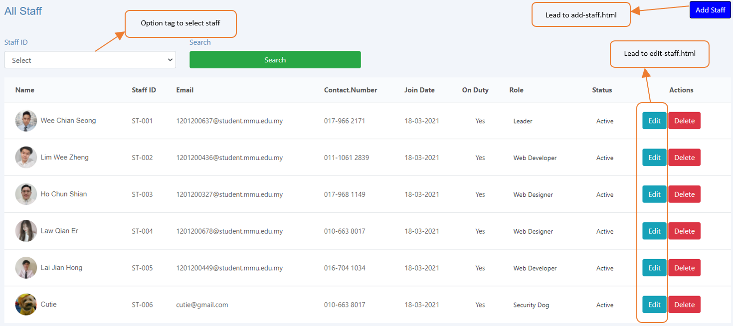

***Figure 2.3.15 All staffs***

*Figure 2.3.15 shows all the staff. The “Edit” buttons lead to edit-staff.html. The “Add Staff” button leads to add-staff.html. The option tag can choose staff to view, by default it shows all staff.*

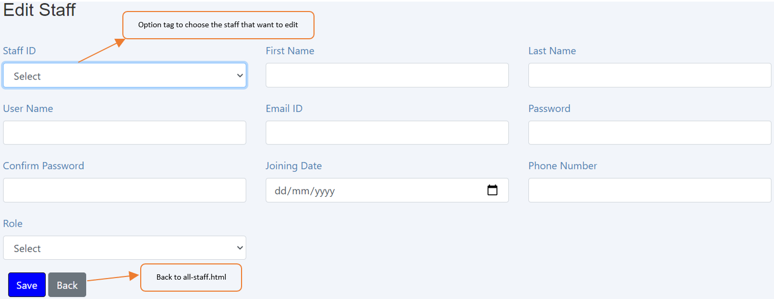

***Figure 2.3.16 Edit Staff***

*Figure 2.3.16 shows the manager can edit staff details. The option tag can choose the Staff ID that wants to edit. The “Back” button can go back to all-staff.html.*

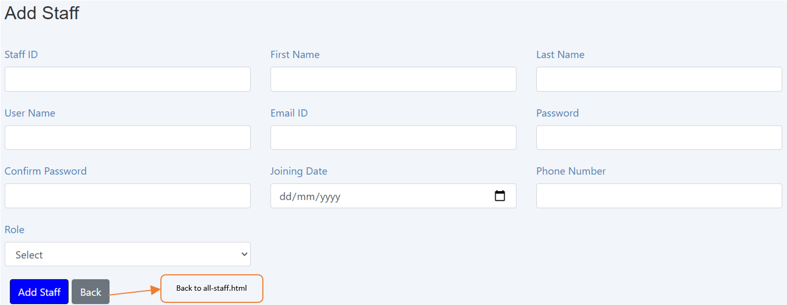

***Figure 2.3.17 Add Staff***

*Figure 2.3.17 shows the manager can add new staff. The “Back” button can go back to all-staff.html.*

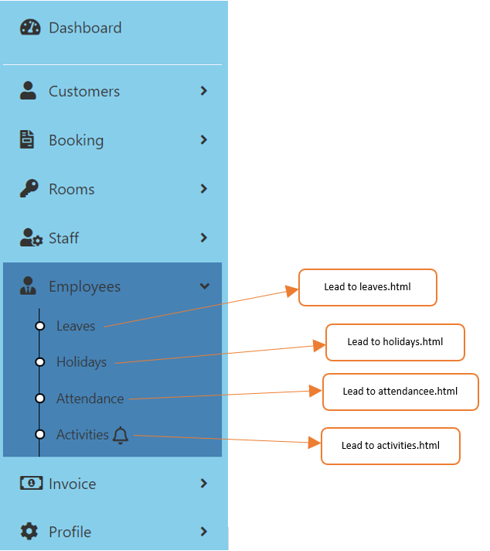

***Figure 2.3.18 Employees in Navigation Bar***

*Figure 2.3.18 shows the pop-down list of “Employees” in the navigation bar. The four bullet lists can lead to leaves.html, holidays.html, attendance.html, activities.html.*

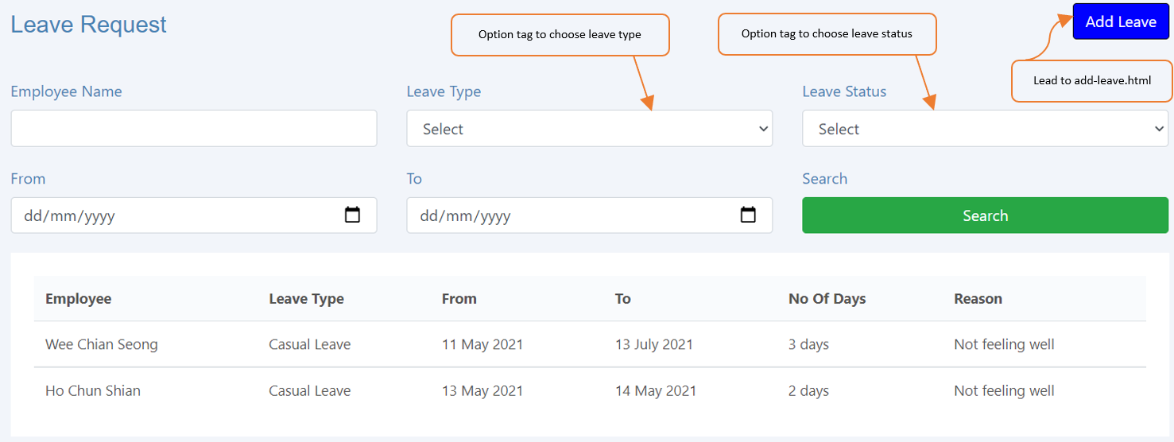

***Figure 2.3.19 All Leaves***

*Figure 2.3.19 shows the leaves requested by staff before. The option tags can choose leave type or leave status to view, by default shows all leave have been requested before. The “Add Leave” button leads to add-leave.html.*

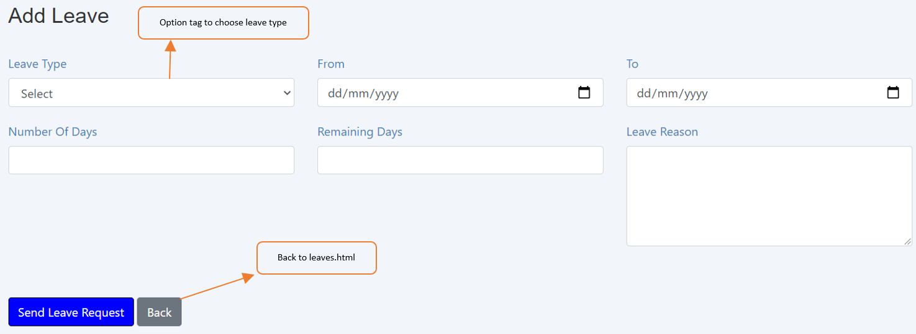

***Figure 2.3.20 Add Leave***

*Figure 2.3.20 shows the manager can add leaves for staff who want to request for leave. The “Back” button can go back to leaves.html.*

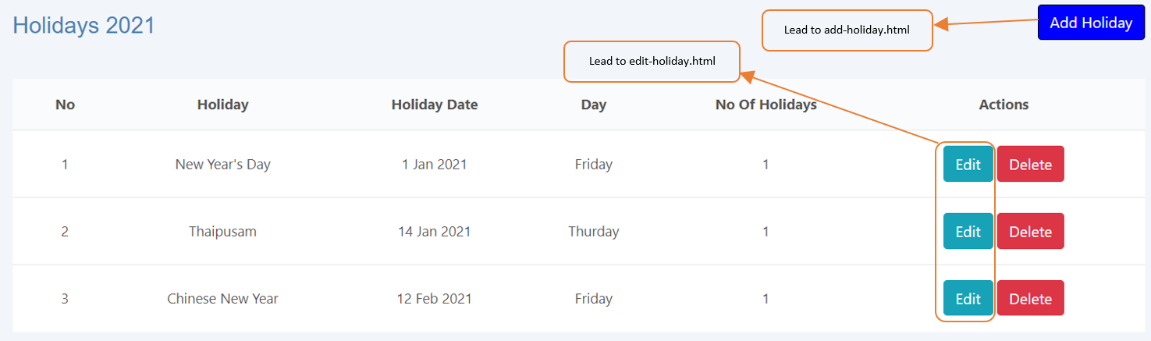

***Figure 2.3.21: Holidays***

*Figure 2.3.21 shows the holidays have been set before. The “Edit” button leads to edit-holiday.html. The “Add Holiday” button leads to add-holiday.html.*

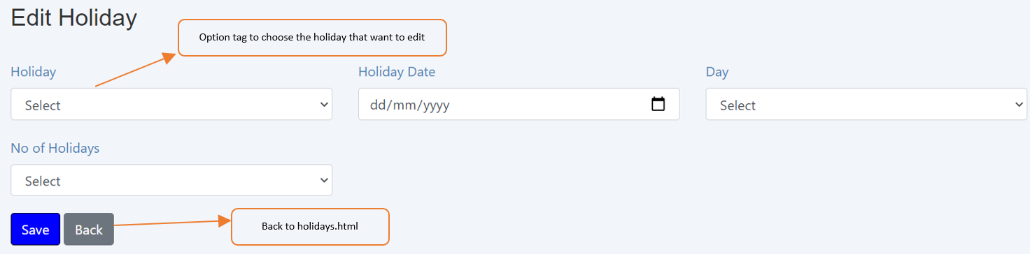

***Figure 2.3.22 Edit Holiday***

*Figure 2.3.22 shows the manager can edit the holiday. The option tag can choose the Holiday that wants to edit. The “Back” button can go back to holidays.html*

*.*

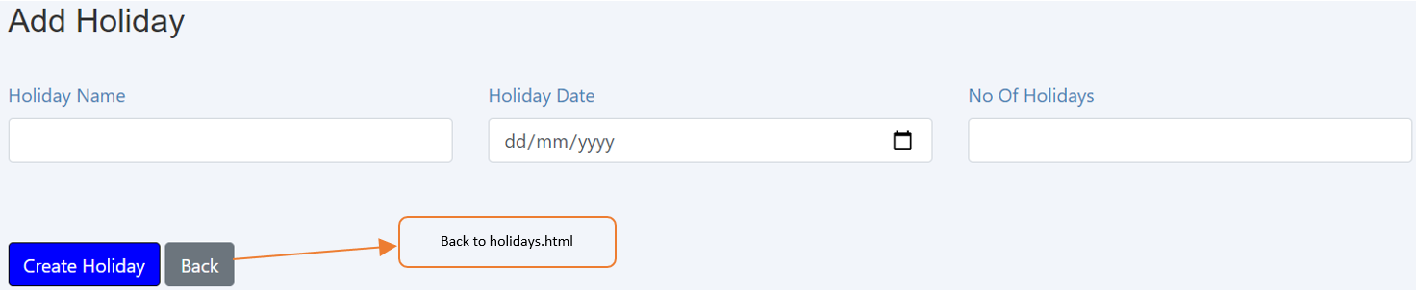

***Figure 2.3.23 Add Holiday***

*Figure 2.3.23 shows the manager can add holiday. The “Back” button can go back to holidays.html.*

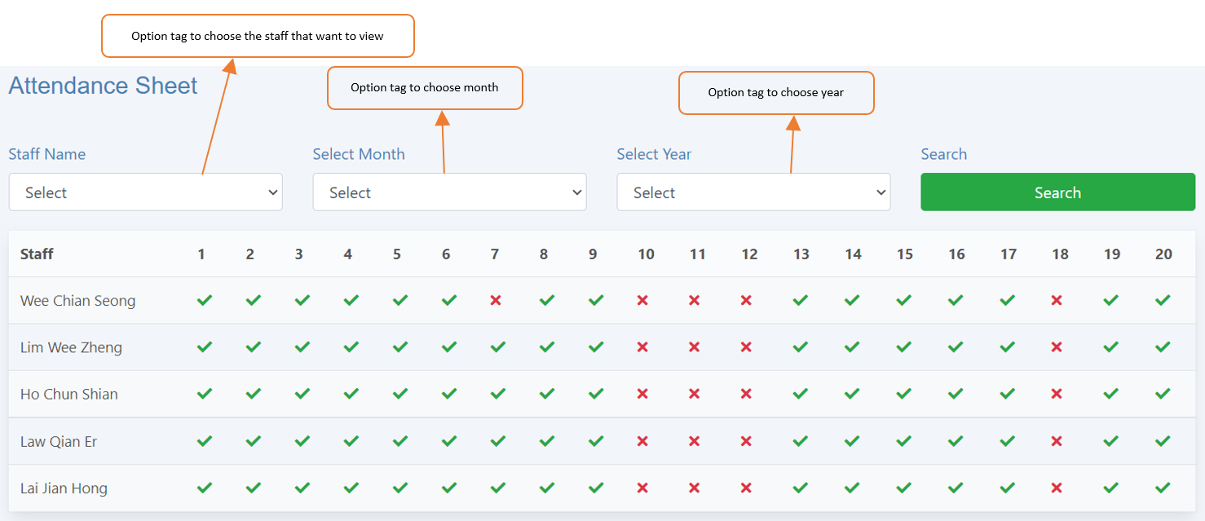

***Figure 2.3.24 Attendance***

*Figure 2.3.24 shows attendance of staff. The first option tag can choose the staff that want to view attendance, by default it shows all staff. The second and third option tag can choose month and year to view.*

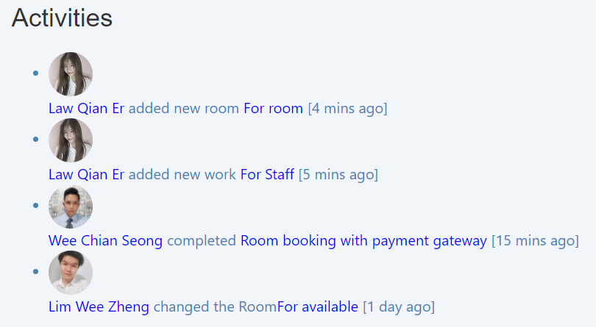

***Figure 2.3.25 Activities***

*Figure 2.3.25 shows the staff did some changes or additions in the system.*

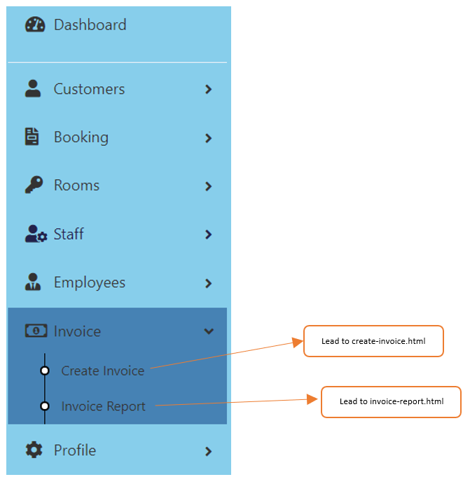

***Figure 2.3.26 Invoice in Navigation Bar***

*Figure 2.3.26 shows the pop-down list of “Invoice” in the navigation bar. The two bullet lists can lead to create-invoice.html and invoice-report.html.*

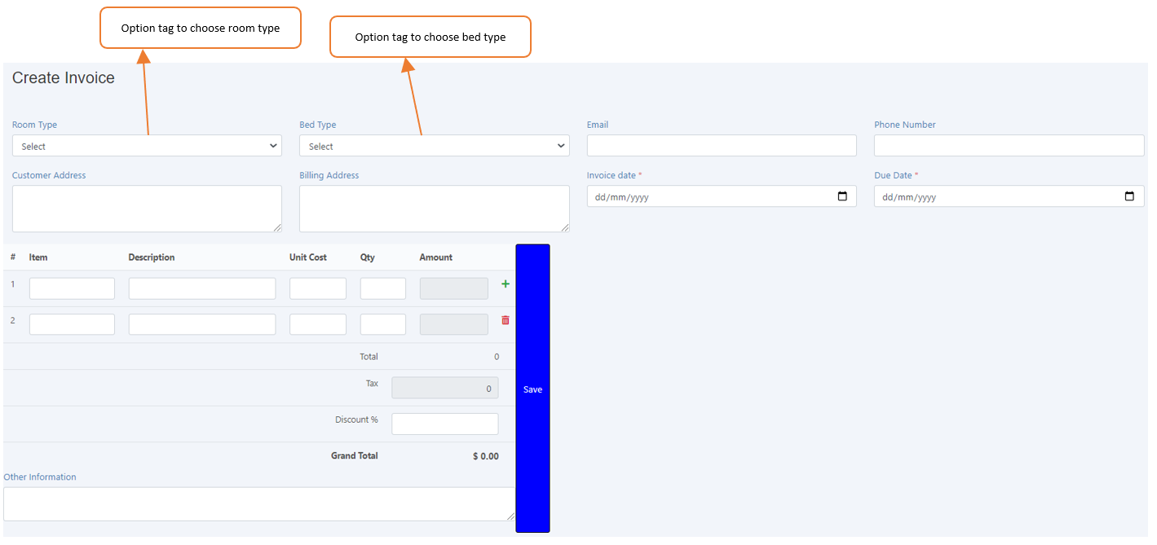

***Figure 2.3.27 Create Invoice***

*Figure 2.3.27 shows the staff can create invoices for customers. The first and second option tag can choose the room type and the bed type that customers want to book.*

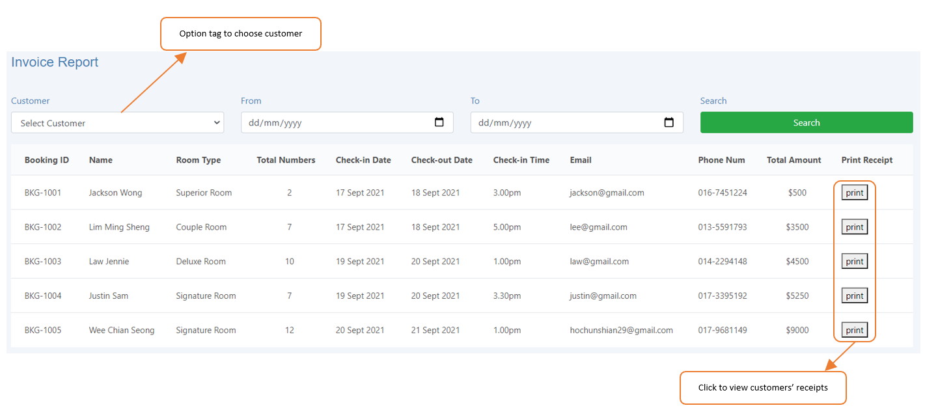

***Figure 2.3.28 Invoice Report***

*Figure 2.3.28 shows the invoice report of customers. The option tag can choose the customer to view his/her details, by default it views all customers. The “print” button can be clicked to view customers’ receipts in pdf format.*

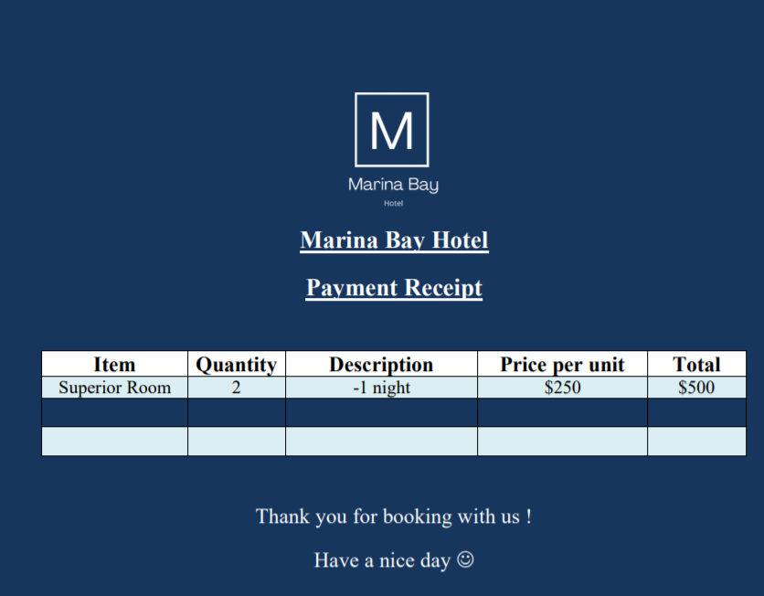

***Figure 2.3.29 Customer’s receipt***

*Figure 2.3.29 shows one of the customer’s receipts in pdf format.*

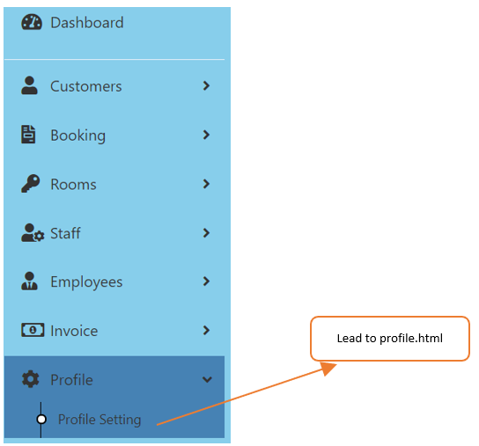

***Figure 2.3.30 Profile in Navigation Bar***

*Figure 2.3.30 shows the pop-down list of “Profile” in the navigation bar. The bullet list can lead to profile.html.*

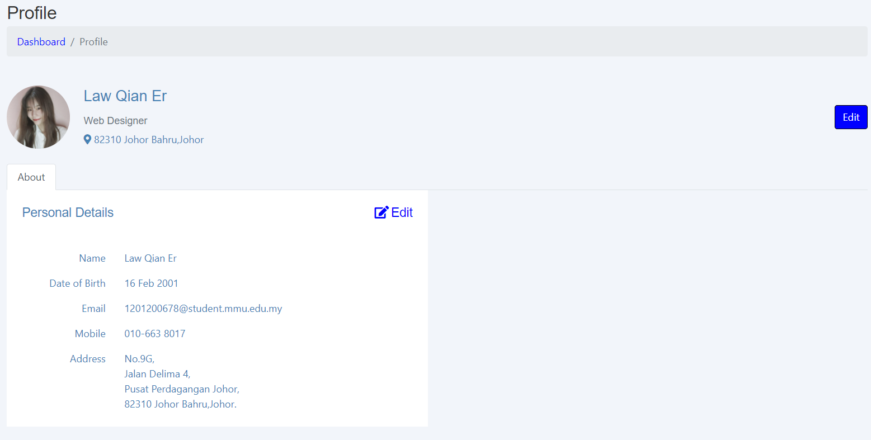

***Figure 2.3.31 Profile***

*Figure 2.3.31 shows the profile of the staff.*

**REFERENCES/BIBLIOGRAPHY**

List of URL addresses or reference books

Public and User:

<https://github.com/W3ndig0u0/MontanaResort>

Admin:

<https://www.soengsouy.com/2021/08/hotel-dashboard-admin-html-css-js-free.html>

**APPENDIX**

|  |  |
| --- | --- |
| **Meeting No.** | 1 |
| **Project Title** | Marina Bay Hotel |
| **Date** | 8 September 2021 |
| **Time** | 8.30 p.m. – 10.30 p.m. |
| **Discussion Platform** | Google meet |

**ATTENDANCE**

|  |  |
| --- | --- |
| **Present** | **Absent** |
| 1. Wee Chian Seong 2. Lim Wee Zheng 3. Law Qian Er 4. Lai Jian Hong 5. Ho Chun Shian |  |

|  |  |  |
| --- | --- | --- |
| **NO** | **ITEM** | **INFO/ACTION** |
| 1 | * 1. Discuss the concept of the user site and how it works.   2. Decided which template to use | All |
| 2 | * 1. Each Group member has to choose two pages to be done from the user pages. | All |
| 3 | 3.1 Due date to submit the part of each member to  leader on 11 August 2021. | All |
|  |  |  |

The meeting adjourned at 10.30 p.m.

Prepared by:

Wee Chian Seong

**APPENDIX**

|  |  |
| --- | --- |
| **Meeting No.** | 2 |
| **Project Title** | Marina Bay Hotel |
| **Date** | 11 September 2021 |
| **Time** | 8.30 p.m. – 10.30 p.m. |
| **Discussion Platform** | Google meet |

**ATTENDANCE**

|  |  |
| --- | --- |
| **Present** | **Absent** |
| 1. Wee Chian Seong 2. Lim Wee Zheng 3. Law Qian Er 4. Lai Jian Hong 5. Ho Chun Shian |  |

|  |  |  |
| --- | --- | --- |
| **NO** | **ITEM** | **INFO/ACTION** |
| 1 | * 1. Help other members to debug .   2. Decided not to continue to use the template. | All  All |
| 2 | * 1. Suggest things to add or delete to all pages.   2. Decide to separate the user into two that is public and user. | All  All |

The meeting adjourned at 10.30 p.m.

Prepared by:

Wee Chian Seong

**APPENDIX**

|  |  |
| --- | --- |
| **Meeting No.** | 3 |
| **Project Title** | Marina Bay Hotel |
| **Date** | 15 September 2021 |
| **Time** | 9.30 p.m. – 12.30 a.m. |
| **Discussion Platform** | Google meet |

**ATTENDANCE**

|  |  |
| --- | --- |
| **Present** | **Absent** |
| 1. Wee Chian Seong 2. Lim Wee Zheng 3. Law Qian Er 4. Lai Jian Hong 5. Ho Chun Shian |  |

|  |  |  |
| --- | --- | --- |
| **NO** | **ITEM** | **INFO/ACTION** |
| 1 | 1.1 Discuss the concept and how it work of admin pages  1.2 Decide which template of admin to use  1.3 Each member choose two pages of admin part | All  All  Lim Wee Zheng, Lai Jian Hong,  Law Qian Er.  Ho Chun Shian |
| 2 | 2.1 Checking and debug user and public pages | All |

The meeting adjourned at 12.30 a.m.

Prepared by:

Wee Chian Seong

**APPENDIX**

|  |  |
| --- | --- |
| **Meeting No.** | 4 |
| **Project Title** | Marina Bay Hotel |
| **Date** | 21 September 2021 |
| **Time** | 9.00 p.m. – 11.00 p.m. |
| **Discussion Platform** | Google meet |

**ATTENDANCE**

|  |  |
| --- | --- |
| **Present** | **Absent** |
| 1. Wee Chian Seong 2. Lim Wee Zheng 3. Law Qian Er 4. Lai Jian Hong 5. Ho Chun Shian |  |

|  |  |  |
| --- | --- | --- |
| **NO** | **ITEM** | **INFO/ACTION** |
| 1 | 1.1 Checking and debug whole part of admin | All |

The meeting adjourned at 11.00 a.m.

Prepared by:

Wee Chian Seong